How to Register a New Substance in G-SRS

As of Version 2.3.7

Table of Contents

Introduction 6

Chemicals 6

Check for Duplicates 6

Global Search 6

Advanced Search (FDA Only) 8

Query Builder 9

Structure Search 10

Chemical Registration 14

Definitional Information 14

Names 16

Structure 18

Codes 18

Relationships 19

Impurity Relationships 20

Metabolite relationships 21

Notes 23

Property 23

References 23

Submit 23

Proteins 25

Check for Duplicates 25

Global Search 25

Sequence Search 25

Protein Registration 27

Definitional Information 27

Names 27

Protein Details 28

Subunits 29

Disulfide Links 29

Other Links 30

Glycosylation 31

Agent Modifications 32

Structural Modifications 33

Physical Modifications 35

Codes 35

Relationships 35

Notes 35

Properties 35

References 35

Submit 35

Nucleic Acids 36

Check for Duplicates 36

Global Search 36

Sequence Search 36

Nucleic Acid Registration 37

Definitional Information 38

Names 38

Nucleic Acid Classification 38

Subunits 39

Sugars 39

Linkages 40

Agent Modifications 40

Structural Modifications 41

Physical Modifications 41

Codes 41

Relationships 41

Notes 41

Properties 41

References 41

Submit 41

Polymers 42

Check for Duplicates 42

Global Search 42

Polymer Registration 42

Definitional Information 42

Names 43

Polymer Classification 43

Monomers and Starting Materials 43

Idealized Structure 44

Structural Units 45

Agent Modifications 46

Structural Modifications 46

Physical Modifications 46

Codes 46

Relationships 47

Notes 47

Properties 47

References 47

Submit 47

Structurally Diverse 48

Check for Duplicates 48

Global Search 48

Structurally Diverse Registration 48

Definitional Information 49

Names 49

Source Material 49

Source Material Record Type 49

Organism Details 50

Hybrid Organism Details 50

Parent Organism Details 51

Parts and Fractions 51

Agent Modifications 52

Structural Modifications 52

Physical Modifications 52

Modifications for Gene and Cell Therapies Example 52

Codes 53

Relationships 53

Notes 53

Properties 53

References 53

Submit 53

Mixture 54

Check for Duplicates 54

Global Search 54

Mixture Registration 54

Definitional Information 55

Names 55

Mixture Details 55

Components 55

Agent Modifications 55

Structural Modifications 55

Physical Modifications 55

Codes 56

Relationships 56

Notes 56

Properties 56

References 56

Submit 56

Concept 57

Concept Registration 57

Names 57

Codes 57

Relationships 58

Notes 58

Properties 58

References 58

Submit 58

# Introduction

This is a guide explaining how to register a new substance (Chemical, Protein, Nucleic Acid, Polymer, Structurally diverse, mixture and concept) in G-SRS. This document contains screen shots from G-SRS version 2.3.7. The chemical and protein registration processes are given in detail and some parts of other substance types refer to these details.

The substance type should be identified, and the correct registration form should be used.

G-SRS system has registration forms for:

1. Chemical
2. Protein
3. Nucleic Acid
4. Polymer
5. Structurally Diverse
6. Mixture
7. Concept
8. Group 1 Specified Substance – will be covered in a future version

# Chemicals

Chemical is a small molecule and single entity. The first step of any registration should be duplicate check. Each substance is unique in G-SRS.

## Check for Duplicates

There are several options to check for duplicates (using all will ensure an exhaustive search):

* Search by name/code (CAS RN or another identifiers) using:
  + Global Search
  + Advanced Search (FDA Only)
  + Query Builder
* Structure search
  + Flex search - insensitive to stereo, salt and isotope
  + Similarity Search - If nothing comes up, do 90-95% similarity search

### Global Search

* 1. Type the name/ code (CAS number or another identifier) on global search box, to search in any substance.
  2. Typehead gives suggestions if there are potential matches, which you can select to go to that specific substance or click  to search.

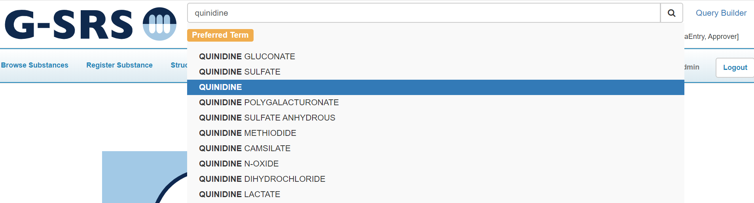

Figure 1 - G-SRS Global Search

* 1. The system has one exact (name or code) match for "QUINIDINE"
  2. The exact match results can be expanded using the Show All Records Matching Search Button

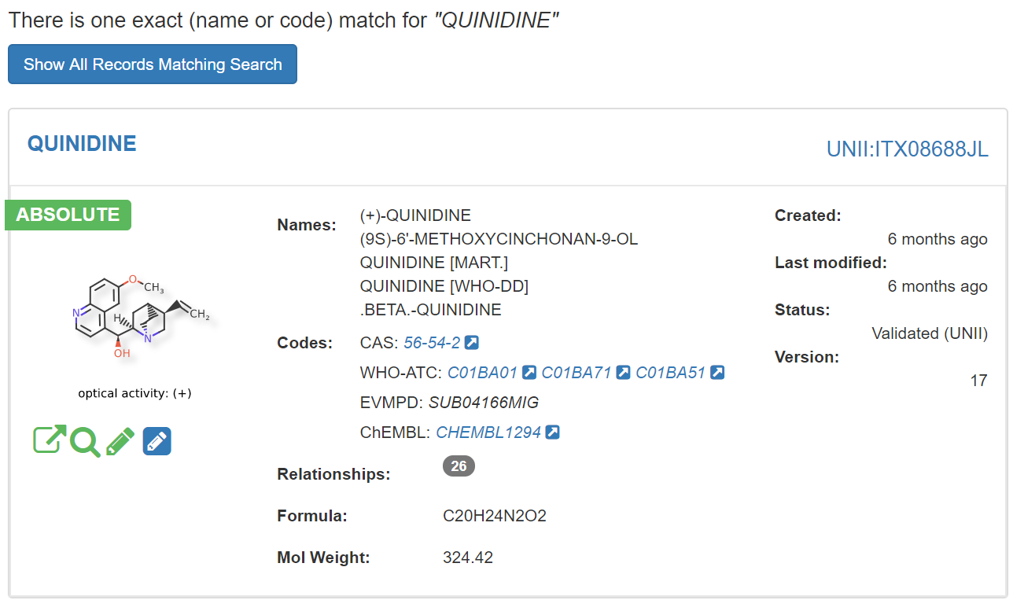

Figure 2 - Global Search Results - Exact Match

* 1. Expansion of search results can be focused for exact or contains match to a specific substance field using the Matches button

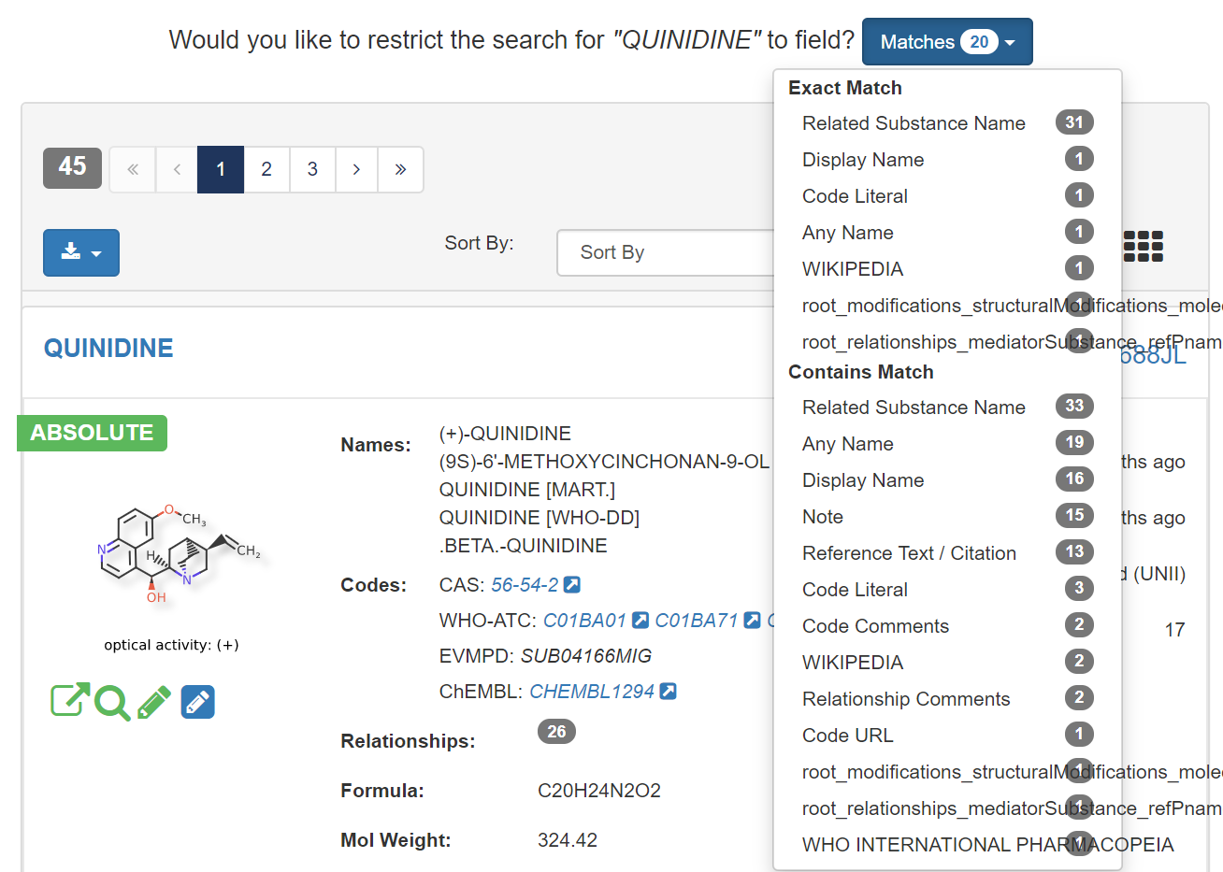

Figure 3 - Global Search Results - Expand Matches

### Advanced Search (FDA Only)

There are few ways to access Advanced Search:

* Next to the Global Search bar, select Advanced Search
* From the navigation pane, select Search > Advanced Search
* From the home page Search section, select either your search type (Substance, Product….) or Advanced Search

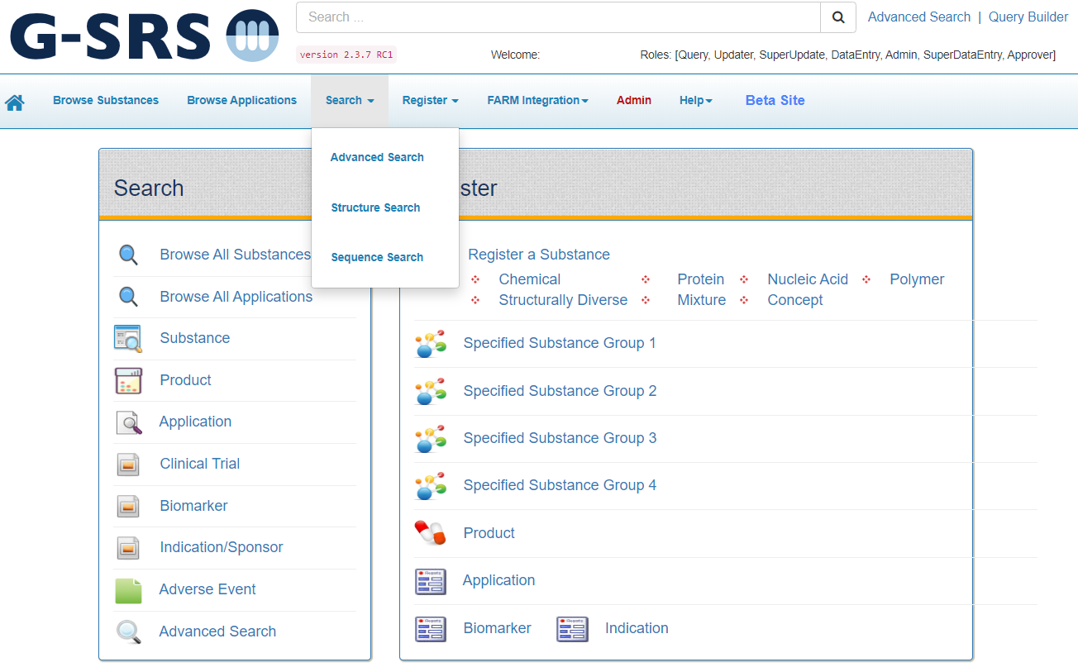

Figure 4 - Accessing Advance Search

1. To check for duplicate substances using Advanced Search make the following selections:
   1. **Substance tab**
   2. **Match by** = Contains
   3. **Search By =** Substance Name
2. Click the Search button
3. Review the results to ensure the new entry is not already represented by another

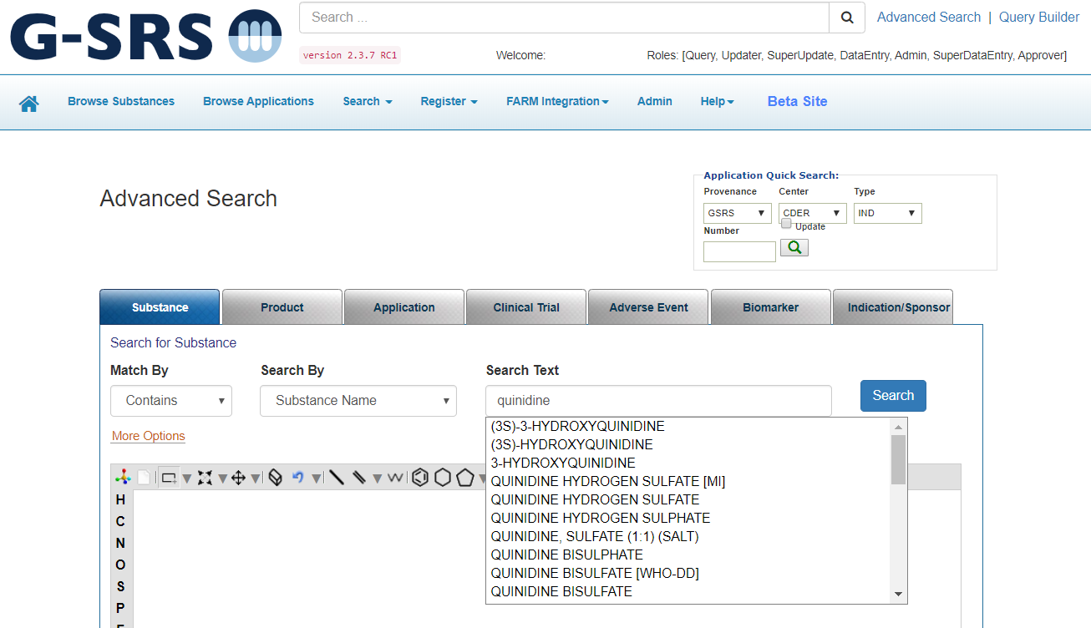

Figure 5 - Advanced Search - Duplicate Check

### Query Builder

To access the Query Builder:

1. Next to the Global Search bar, select Query Builder

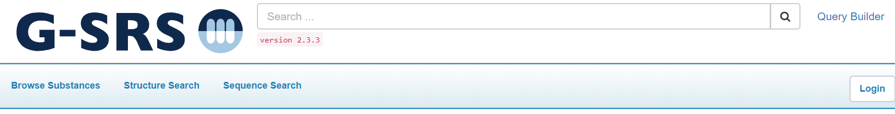

Figure 6 - Accessing Query Builder

1. Initially the screen will fade out, click the Guide Me link

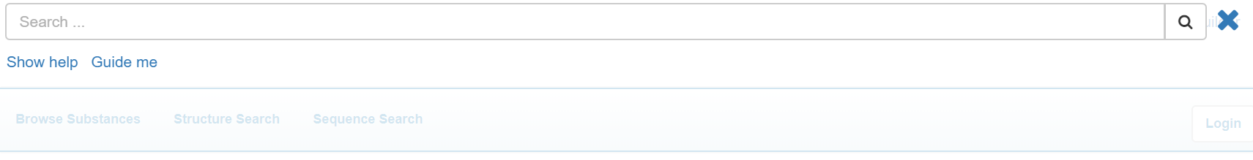

Figure 7- Query Builder - Guide Me Link

1. The guided Query Builder screen is displayed
   1. Ex: If we have a new drug extracted from pseudolysimachion rotundum subsp. subintegrum aerial parts and active ingredient of this drug is verproside

Figure 8 - Query Builder – Criteria

1. From the results, the new substance might be YPL-001, currently in GSRS as a concept

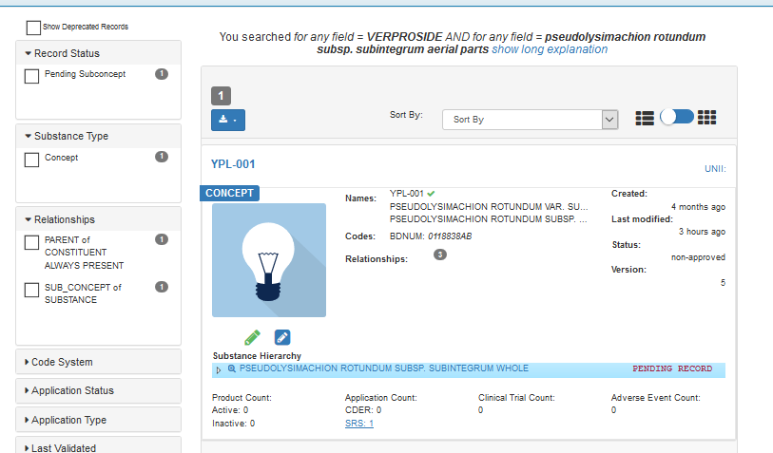

Figure 9 - Query Builder - Results

### Structure Search

To access Structure Search:

1. From the navigation pane, select Structure search

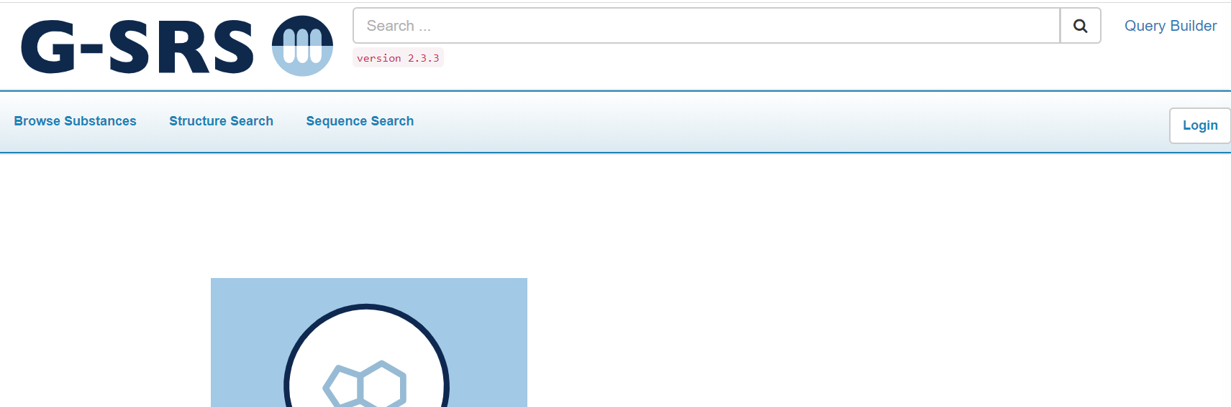

Figure 10 - Accessing Structure Search

1. The Draw Structure canvas displays the JSdraw plug-in. There are several options to use the structure search:
   1. Load Image (via copy/paste or drag local file)
   2. Import Image File
   3. Import text/Molfile
   4. “Get Structure from Name” by typing the substance name > Click Resolve Name

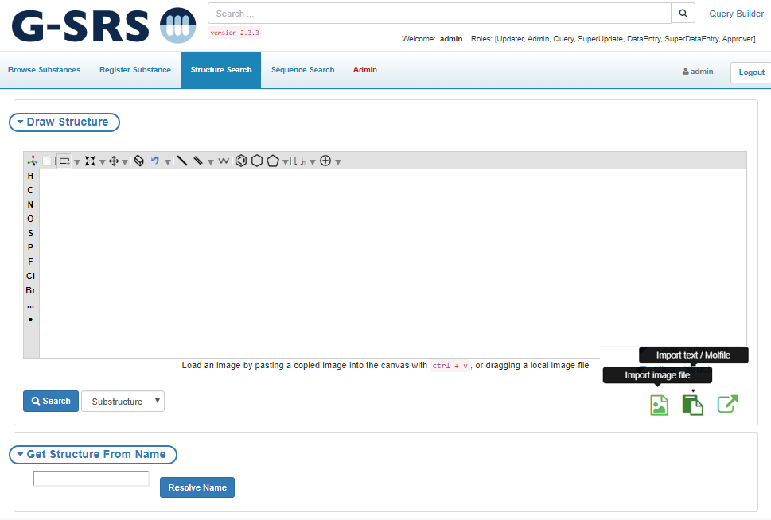

Figure 11 - Structure Search Options

1. Load Image - GSRS can convert images to structures when it is pasted onto the canvas
   1. Copy the source image (ctrl+c) > Click on canvas (canvas border will turn to blue) > press ctrl+v or drag a local image file
   2. Minor adjustments may be required, in the following, the circled bond was not converted

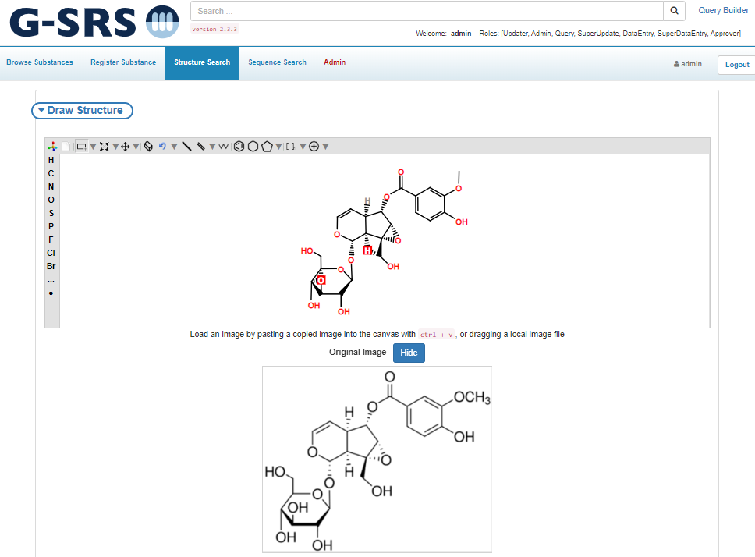

Figure 12 - Structure Search - Import Image File

1. Import Image File button
   1. Click the Import Image File button
   2. There are two tabs at the top of the Import prompt, but it defaults to Image
      1. Click Browse to navigate to your image file and import

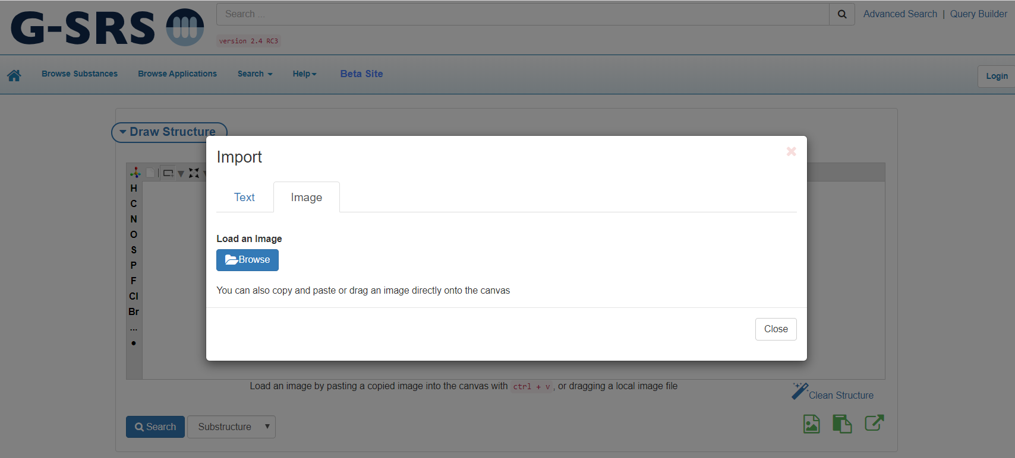

Figure 13 - Structure Search – Image Import Prompt

1. Import text/Molfile button
   1. Browse to your molfile or copy/paste the text of a smiles string directly into the text box
      1. Scifinder provides an option to export mole files
      2. Accelry Draw and Chemdraw generate structures from systematic names

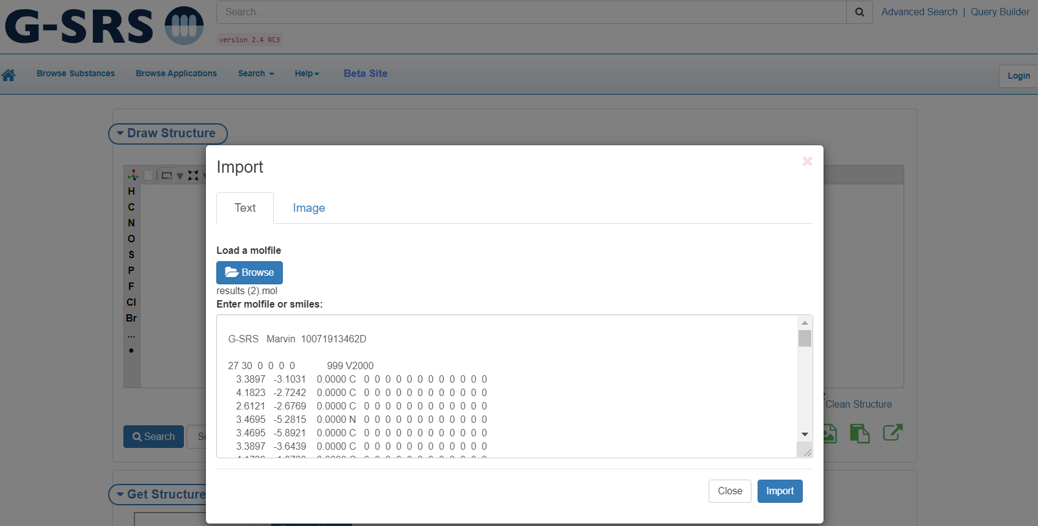

Figure 14 - Structure Search – Text/Molfile Import Prompt

1. If your duplicate search is exhausted and you are ready to register your substance, you can use a structure generated by the GSRS structure search.
   1. From your Structure Search canvas, select “Clean Structure”
   2. Make any modifications to your structure you would like retained for registration
   3. Click the Export button

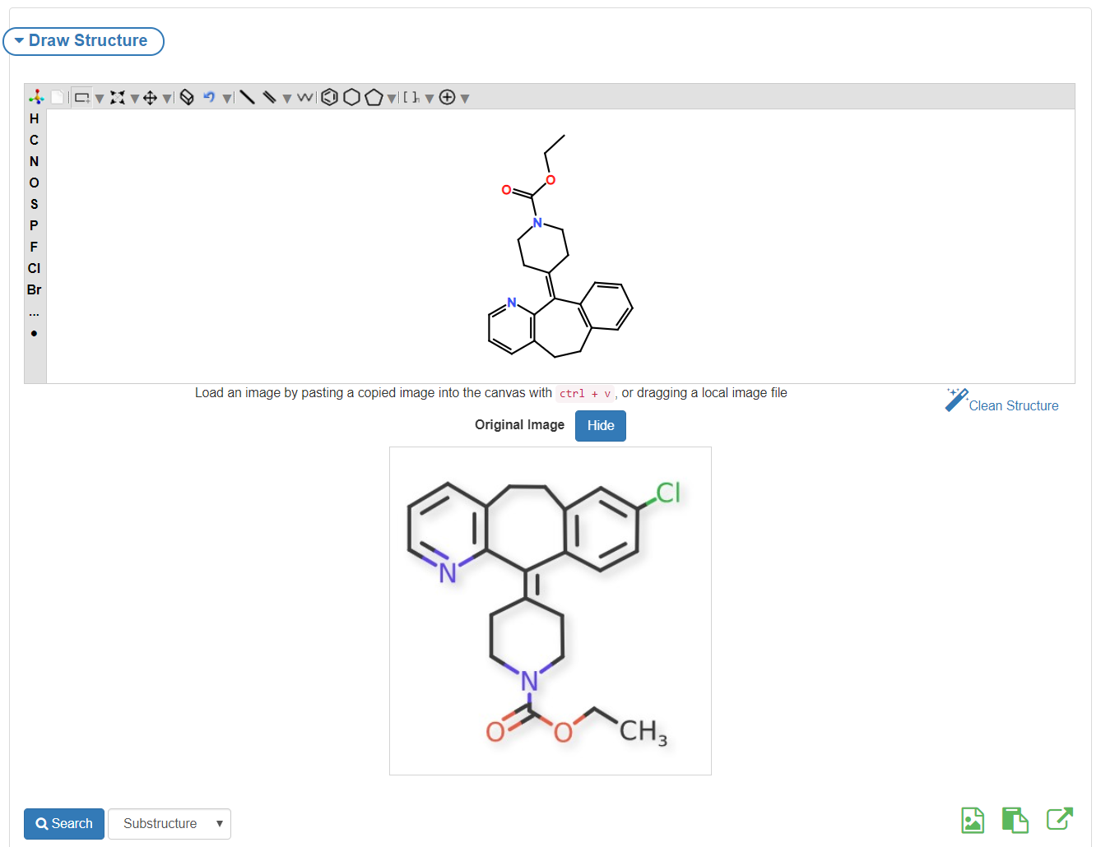

Figure 15 - Structure Search - Export Structure File

* 1. At the prompt, click the download button and the file will be saved locally when you are ready to re-use.

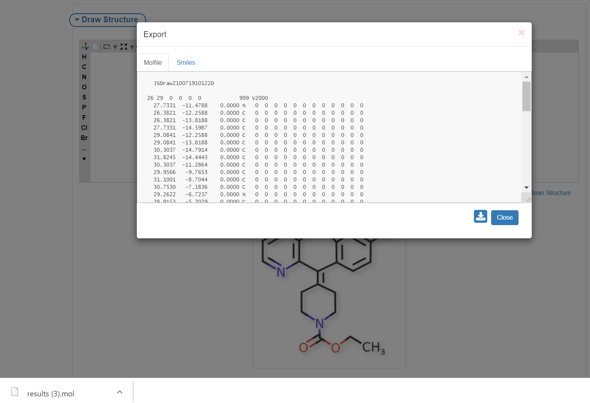

Figure 16 - Structure Search - Download Structure Export

## Chemical Registration

After verifying the substance is not registered in GSRS, use the Chemical Registration form to register the new substance. User accounts with registration permissions will have access to the registration menus. If you believe your account is not properly configured, contact your site admin.

1. From the GSRS homepage navigation pane, select Register Substance
2. All substance types will be displayed, select “Register a Chemical”

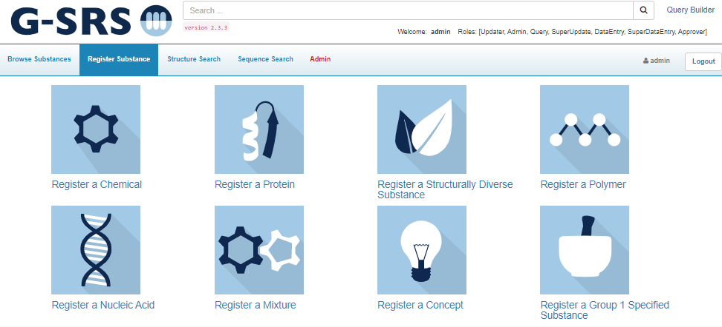

Figure 17 - Homepage > Register Substance

1. The chemical registration form will be displayed. Section cards are collapsible to ease navigation, however the elements in this form are:
   1. Definitional Information
   2. Names
   3. Structure
   4. Code
   5. Relationships
   6. Notes
   7. Properties
   8. References

### Definitional Information

1. Definition Type - hover over and click to activate the Edit drop-down. There are two options:
   1. Primary
   2. Alternative - Chemical alternative definition of a protein, nucleic acid, polymer, ring/open sugar etc.
      1. Type the Primary Substance name in search box and select
      2. After submission, the system generates a relationship connecting both definitions
      3. Alternative definition registration is similar to Primary definitions, but Names and Codes are not included
2. Definition Level - hover over and click to activate the Edit drop-down.
   1. Always try to enter a Complete definition
   2. Incomplete and Representative definition levels are allowed for incompletely defined substances

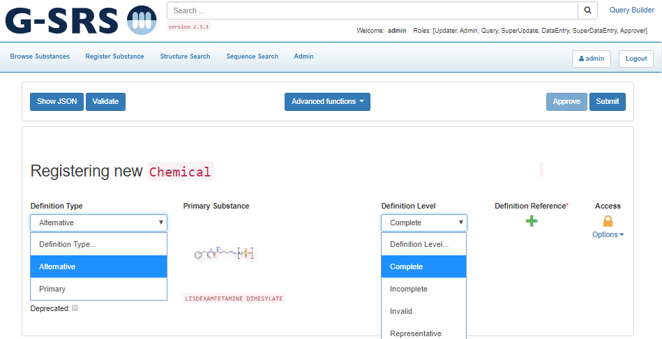

Figure 18 - Register Chemical - Definitional Information

1. Reference(s) – click the + button
   1. At the References prompt, click the + Add Reference button, additional fields will be displayed
      1. Select Source Type
      2. Add Source Text/Citation
      3. Based on the release sensitivity,
         1. Check Public Domain if public
            1. If public, click Show Details and add Tags for Public-Domain-Release
         2. Update the Access
   2. Update the Access Options: Uncheck all the options of the drop down if the substance is from a public source, otherwise mark Protected
      1. Click Show Details
         1. Add Source Class, URL, Source Id
         2. Add the Public Domain Release tag if the substance is from public sources
         3. Upload a Document with the Browse button to add a reference document
   3. Click the Apply checkbox to ensure the Reference is associated with the definition
   4. Click Save & Close

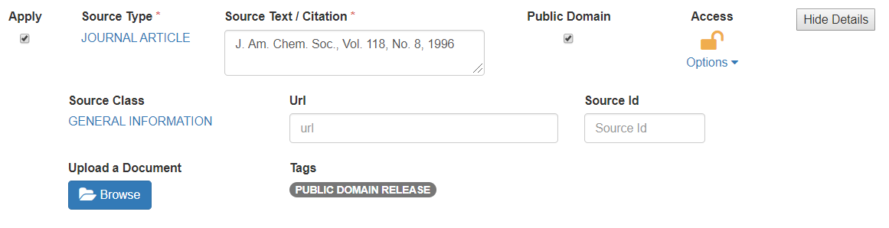

Figure 19 - Register Chemical - Definitional Information – Add References

1. Verify the Reference is attached to the Definition
   1. The  is replaced with  number will correspond to the number of references added
2. Click on Add references to add more references

### Names

The Names card accommodates multiple names. By default, the section is collapsed but can be expanded to view more names.

1. Click the Add name button

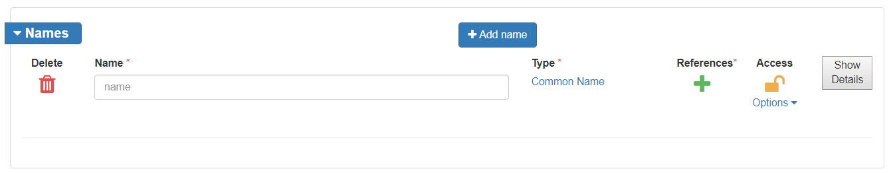

Figure 20 - Register Chemical – Names

1. Names should be:
   1. All CAPS
   2. No Brackets – use parenthesis for brackets
2. Select Type
3. Add a Reference – a reference is required. If references already exist, you can select an existing reference or Add a Reference
4. Set the Access level
5. Click Show Details to provide additional information
   1. Languages
   2. Display Name – each substance record required to have one, this name will be indicated with a on the Browse/search results

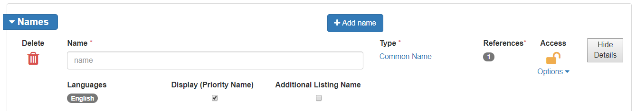

Figure 21 - Register Chemical - Names - Show Details

1. When Type is Official Name, there will be additional Details for:
   1. Domains
   2. Name Orgs
   3. Name Jurisdiction

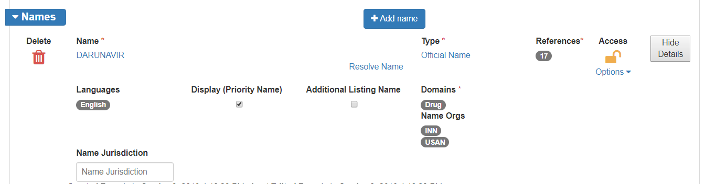

Figure 22 - Register Chemical - Names - Official Details

1. Use the Standardize Names from the Advanced Functions menu prior to submitting the substance

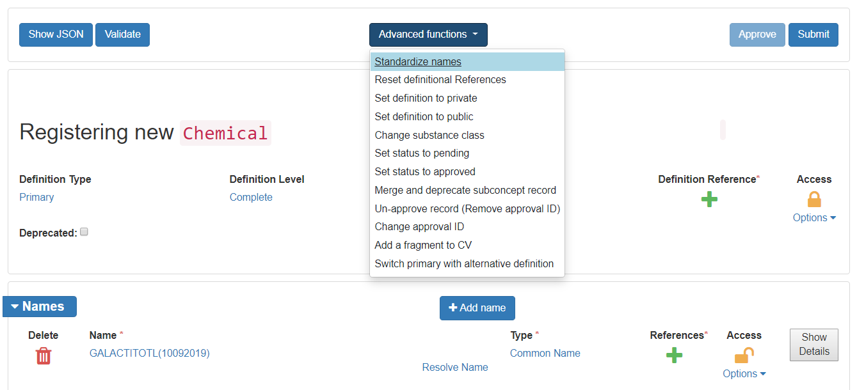

Figure 23 - Register Chemical - Standardize Names Advanced Function

### Structure

Use any method described in the Duplicate Search > Structure Search section to upload a structure.

1. After entering the structure in the JSDraw canvas, click Check for Duplicates button
2. Verify the system correctly auto populated the remaining fields:
   1. Molecular Formula
   2. Stereochemistry – calculated based on stereo bond, update as needed
      1. Ex: Asenapine is racemic, however G-SRS would identify as absolute chiral
   3. Optical Activity
   4. Additional Stereochemistry
   5. Molecular Weight
   6. Defined Stereocenters
   7. EZ Centers
   8. Structure Charge
   9. Access – update to Protected for nonpublic substances

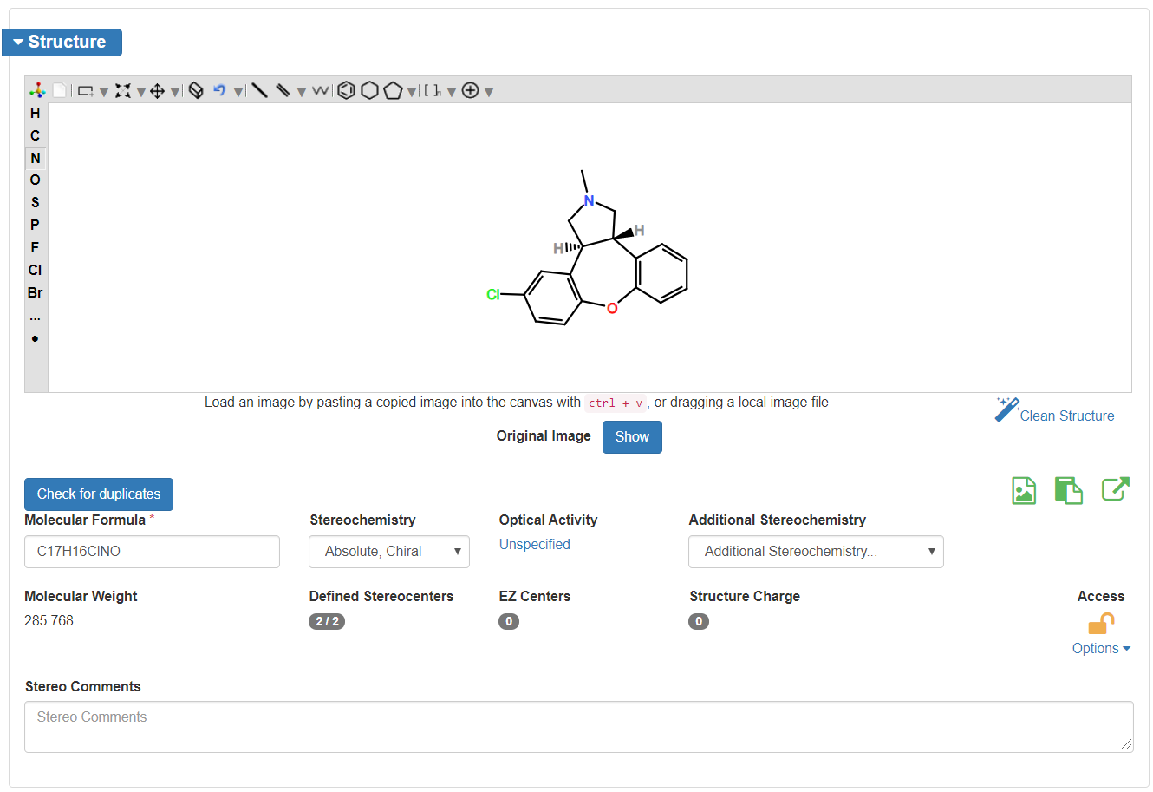

Figure 24 - Register Chemical - Structure

### Codes

The Codes card accommodates multiple codes. By default, the section is collapsed but can be expanded to view more codes.

1. Expand the Codes card
2. Click the Add a code button

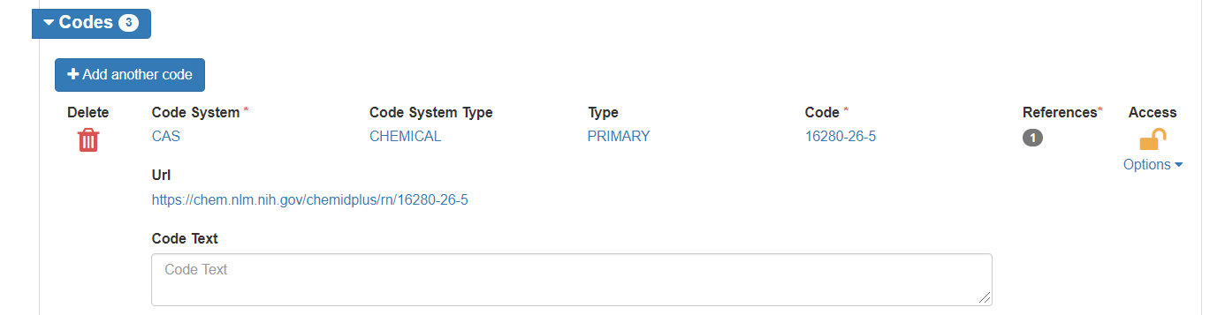

Figure 25 - Register Chemical - Codes

1. G-SRS will automatically construct URLs for the following Code Systems

|  |  |  |
| --- | --- | --- |
| ALANWOOD | GRIN | NCI_THESAURUS |
| CAS | INN | NDF-RT |
| CFR | ITIS | PHAROS |
| CHEMBL | IUPHAR | PUBCHEM |
| CLINICAL_TRIALS.GOV | JECFA EVALUATION | RXCUI |
| CODEX ALIMENTARIUS (GSFA) | JMPR-PESTICIDE RESIDUE | UNIPROT |
| DEA NO. | MERCK INDEX | USDA PLANTS |
| DRUG BANK | MEX | WHO-ATC |
| FOOD CONTANT SUBSTANCE NOTIF, (FCN NO.) | NCBI TAXONOMY |  |

Figure 26 - Register Chemicals - URL Construction for Code Systems

1. A reference is required. If references already exist, you can select an existing reference or Add a Reference

### Relationships

The relationships card accommodates multiple relationships. By default, the section is collapsed but can be expanded to view more relationships. When relationships are added, the inverse relationship is added to the source and target related substance.

1. Expand the Relationships card
2. Click the Add a relationship button
3. Both the Related Substance and Mediator Substance are search fields. Typeahead is also available for these fields.
   1. Begin entering the name
   2. Select the correct substance if more than one
   3. If no matching substances are returned, you cannot create a relationship to an unregistered substance
4. Select relationship Type
5. Other fields are optional

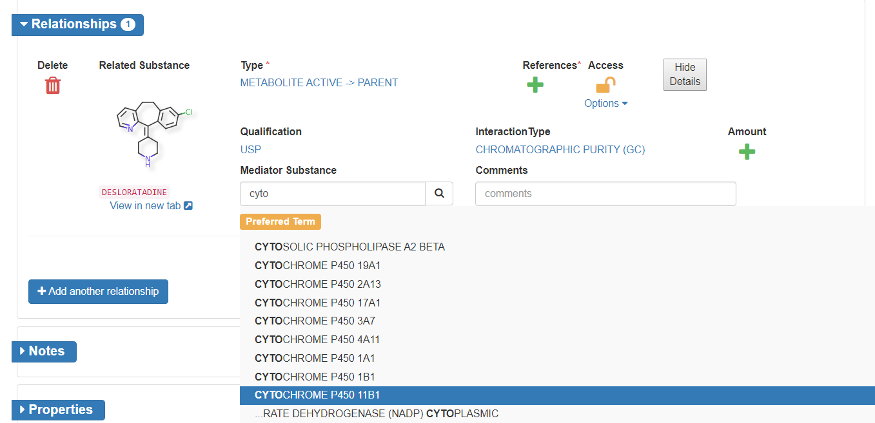

Figure 27 - Register Chemical - Relationships Basic

Impurity Relationships should be added to active ingredient - to the salt record, if the substance is a salt

1. The relationship Type should be IMPURITY 🡪 PARENT
   1. The related substance is always on left side of the arrow and main substance is on right side of the arrow

EX: PRASUGREL HYDROCHLORIDE is in USAN (<https://online.uspnf.com/uspnf/document/GUID-6F4D7843-1F3E-43B5-949B-F88DBD6DFA74_5_en-US?highlight=Prasugrel%20Hydrochloride>)

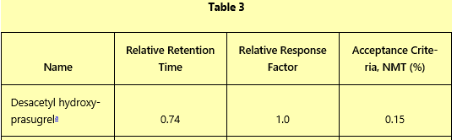

Figure 28 - Register Chemical - Relationships - IMPURITIES USP/NF monograph; Mode LC

1. Based on this information, the additional details are:
   1. Qualification = USP
   2. Interaction Type = ASSAY (HPLC)

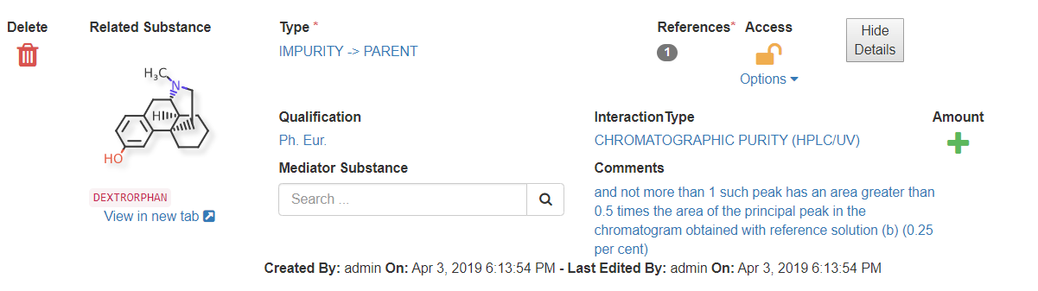

Figure 29 - Register Chemical - Relationships - Impurity Details

1. To add the USAN specification of this impurity is “NOT MORE THAN” 0.15 %”, click on  under Amount to add amount.
   1. Select the amount Type
   2. Enter “0.15” as the HighLimit

Figure 30 - Register Chemical - Relationships - Amount

Metabolite relationships always link to active moiety/prodrug. The relationship options between metabolites and the active moiety/prodrug are:

* Active
* Active 🡪 (as) Parent
* Active 🡪 Prodrug
* Inactive 🡪 Parent
* Less Active 🡪 Parent
* 🡪 Parent (unknown)
* Toxic 🡪 Parent (without any activation)
* Reactive Type🡪 Parent
  + Those should be covalently bind to proteins and nucleic acids for the toxicity

<https://www.ncbi.nlm.nih.gov/pmc/articles/PMC2952084/>

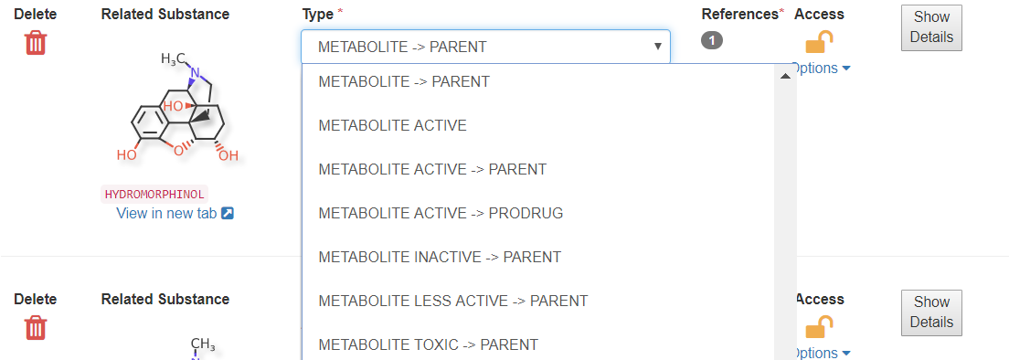

Figure 31 - Register Chemical - Relationships - Metabolite Types

Example: Noroxymorphone is an active metabolite of oxycodone.

1. Edit Oxycodone
2. In the Relationships card, click Add another relationship
3. In Related Substance, search and select “Noroxymorphone”
4. For Type, select “METABOLITE ACTIVE -> PARENT”
5. Add a Reference – a reference is required. If references already exist, you can select an existing reference or Add a Reference

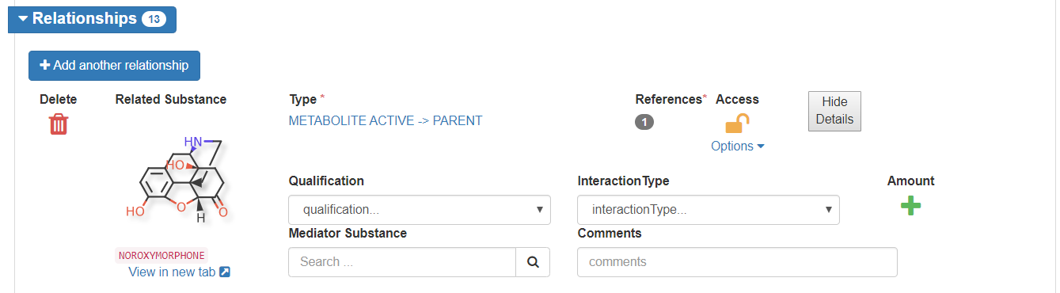

Figure 32 - Register Chemical - Relationships - Noroxymorphone Metabolite

Example: R-138727 is an active metabolite of Prasugrel, which is a prodrug. R-138727 is a mixture of four isomers. It is a major metabolite in plasma and two step conversion. First step is mediated by esterase (not specified) second step is mediated by four CYP enzymes. So, one relationship should be added for each CYP enzyme.

<https://accpjournals.onlinelibrary.wiley.com/doi/pdf/10.1592/phco.29.9.1089>

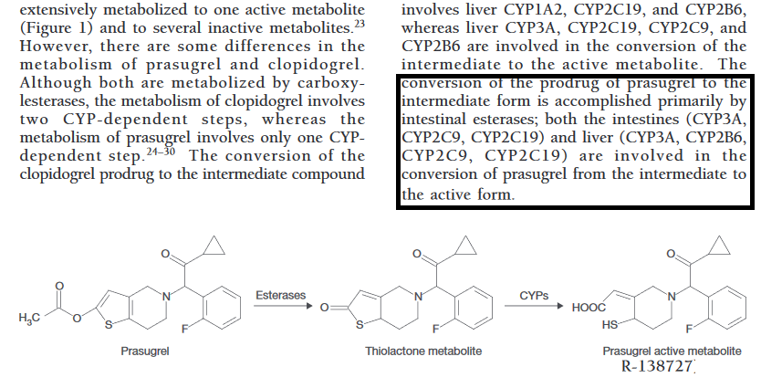

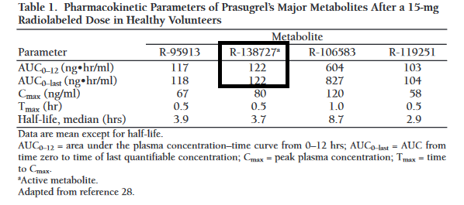

Figure 33 - Extracts of Pharmacokinetics and Pharmacodynamics of Prasugrel, a Thienopryridine P2Y12 Inhibitor

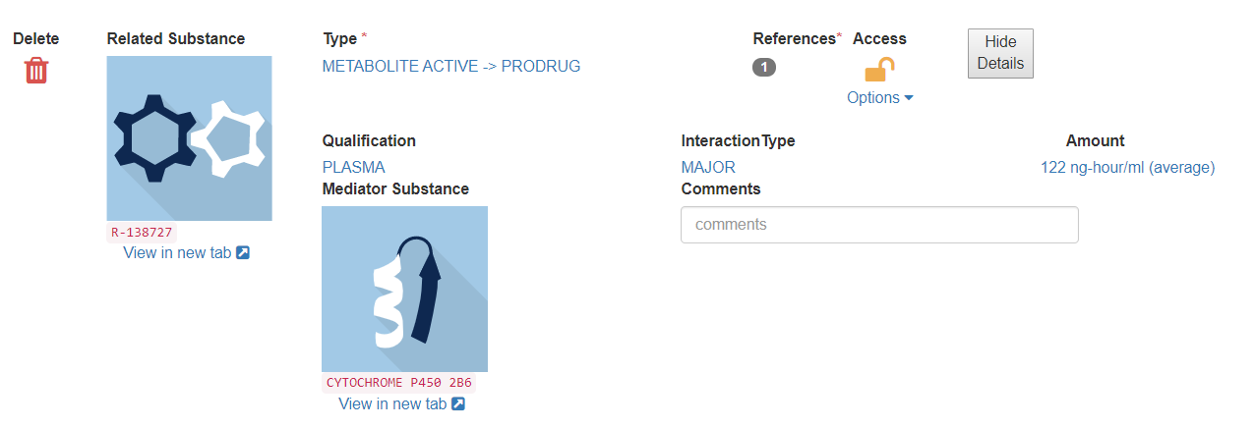

Figure 34 - Register Chemical - Relationships – Metabolite for Prasugrel

### Notes

While you can add a note, you will notice that notes will also be automatically added to track Warning messages and other information related to substance validation.

### Property

Additional substance details can be added to the Properties card.

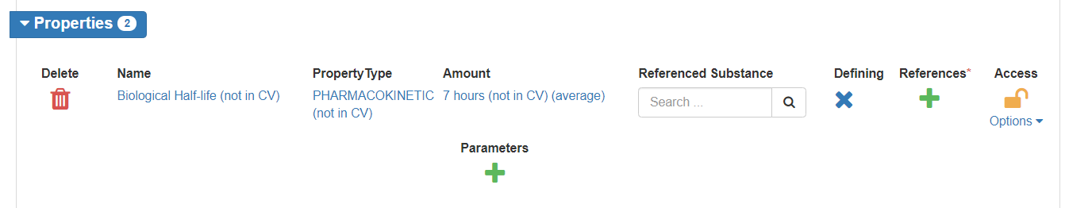

Figure 35 - Register Chemical – Properties (Prasugrel)

### References

The References card automatically accumulate the references added during registration in one section. References can be added, updated, or removed from this card.

### Submit

1. Submit the substance by clicking Submit button on top right-hand corner
2. GSRS will validate the submission, you may receive prompts for
   1. Errors (red) – substances with errors cannot be submitted, click Go Back to return to the substance form, make corrections and resubmit
   2. Warnings (yellow) – warnings should be reviewed
      1. If warnings are accepted, click Dismiss and continue
      2. If warnings should be address, click Go Back to return to the substance form, make corrections and resubmit

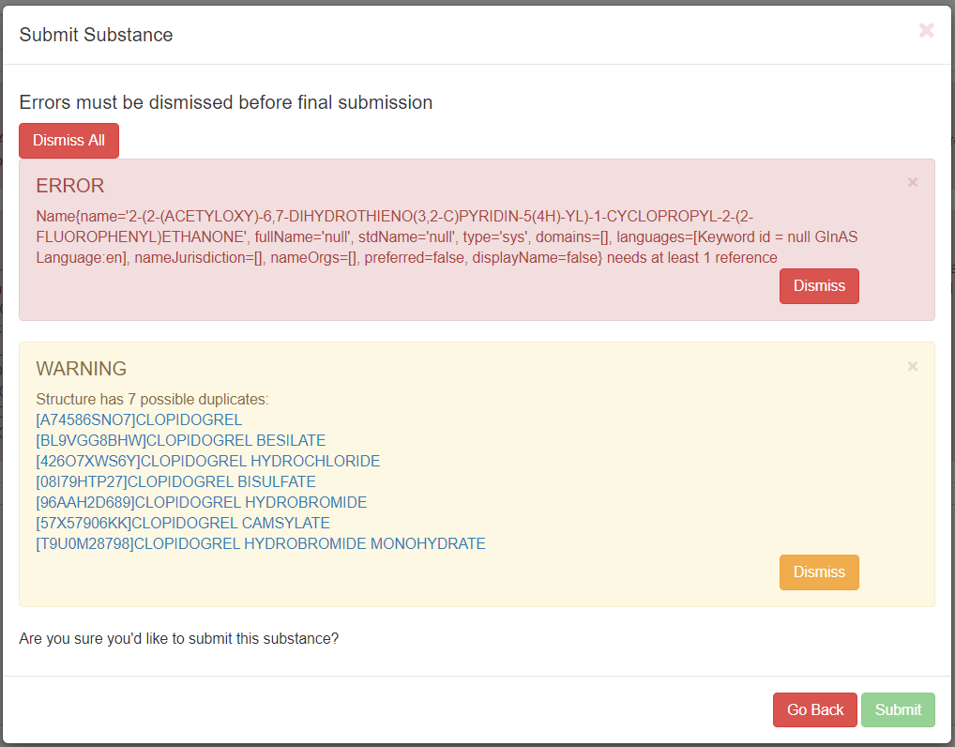

Figure 36 - Register Chemical - Submission Validation

1. After successfully submitted you will have the following options:
   1. Continue Editing – the registration form remains, and changes can be made
   2. Return to Browse – loads the Browse Substances screen
   3. View Substance – displays the current substance in view-only mode

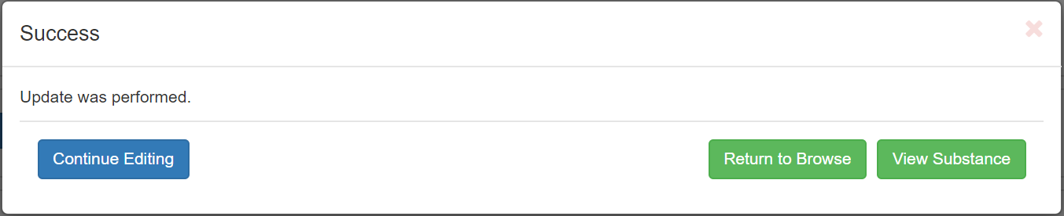

Figure 37 - Register Chemical – Submission

# Proteins

## Check for Duplicates

### Global Search

Utilize the Global Search option similar to the Chemical Registration duplicate check

### Sequence Search

1. From the navigation pane, select Sequence Search

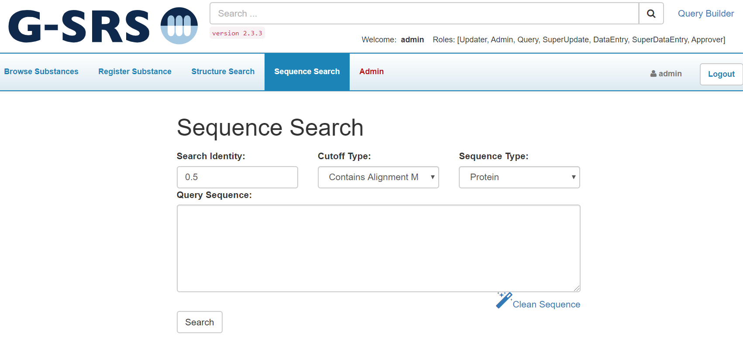

Figure 38 - Sequence Search

1. Set Search Identity and Cutoff Type
   1. For a full sequence, 0.95/Global alignment match is a reasonable set up for duplicate search
      1. This is similar to a flex search for chemical structure.
   2. Contains Alignment Match is good for partial sequences.
2. Paste the sequence in Query Sequence box and click Clean Sequence.
   1. The Clean Sequence tool removes numbers, spaces etc.
3. Click search.

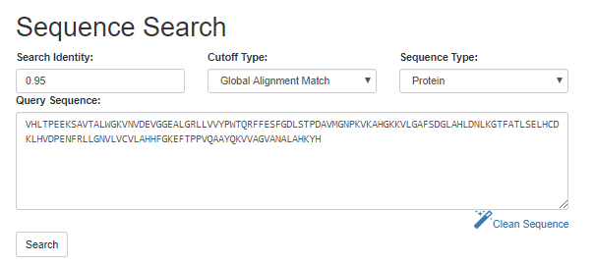

Figure 39 - Sequence Search - Criteria

1. Review the results/ alignment match to identify any duplicate (Figure 2.2).

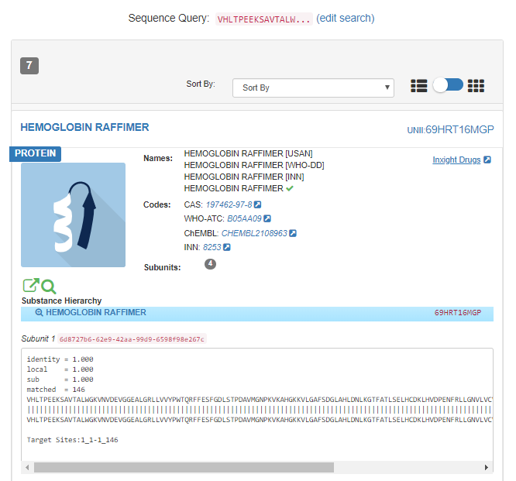

Figure 40 - Sequence Search - Results

## Protein Registration

After verifying the substance is not registered in GSRS, use the Protein Registration form to register the new substance. User accounts with registration permissions will have access to the registration menus. If you believe your account is not properly configured, contact your site admin.

1. From the GSRS homepage navigation pane, select Register Substance
2. All substance types will be displayed, select “Register a Protein”



Figure 41 - GSRS Homepage - Register Substances

1. The protein registration form will be displayed. Section cards are collapsible to ease navigation, however the elements in this form are:
2. Definitional Information
3. Names
4. Protein Details
5. Subunits
6. Disulfide links
7. Other links
8. Glycosylation
9. Agent modification
10. Structural modification
11. Physical modification
12. Code
13. Relationships
14. Notes
15. Properties
16. References

### Definitional Information

Same as in Chemical registration - Definitional Information

### Names

Same as in Chemical registration - Names

### Protein Details

1. Add Protein Details for: Protein Type, Protein SubType, Sequence Origin, Sequence Type and Access level
   1. Access level should be set to protected if the sequence information is not public, even if name and target information is public

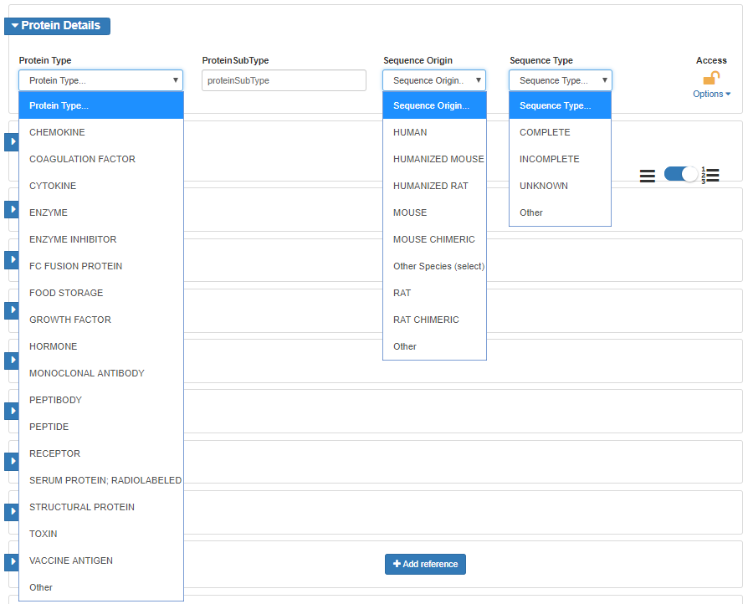

Figure 42 - Protein Registration - Protein Details Card

### Subunits

Add subunits one at a time.

1. Click Subunits to expand the card
2. Click Add a subunit button
3. Click the Edit Sequence button
4. Paste the sequence in to the canvas
5. Click the Clean Sequence button  , this tool removes numbers, spaces if any
6. Click Save Sequence
7. Click Add another subunit button to add more subunits

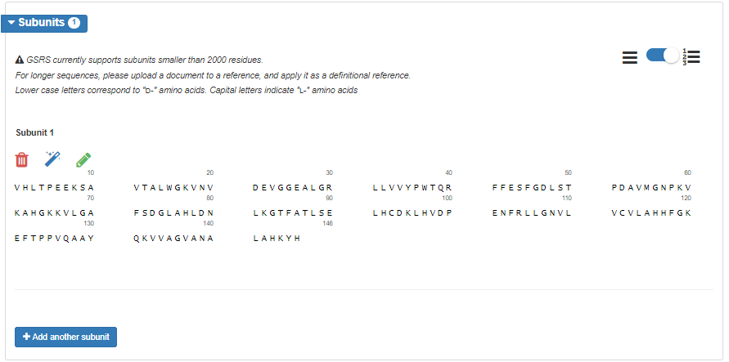

Figure 43 - Protein Registration – Subunits

### Disulfide Links

Figure 44 – Protein Registration – Disulfide Links

Add disulfide links one at a time with the pre-populated sites for pairing

1. Click Disulfide Links to expand the card
2. Click Add a link button
3. Select Cysteine moieties pairs from the list
4. Repeat for each pair

### Other Links

Figure 45 - Register Protein - Other Links - Linkage Type

Add other links one at time.

1. Click Other Links to expand the card
2. Click Add a Link
3. Select the Linkage Type
4. Click Site, a new pop-up will be displayed with the populated subunits. Select the subunit and the site will populate. Click Close
5. Repeat for each pair

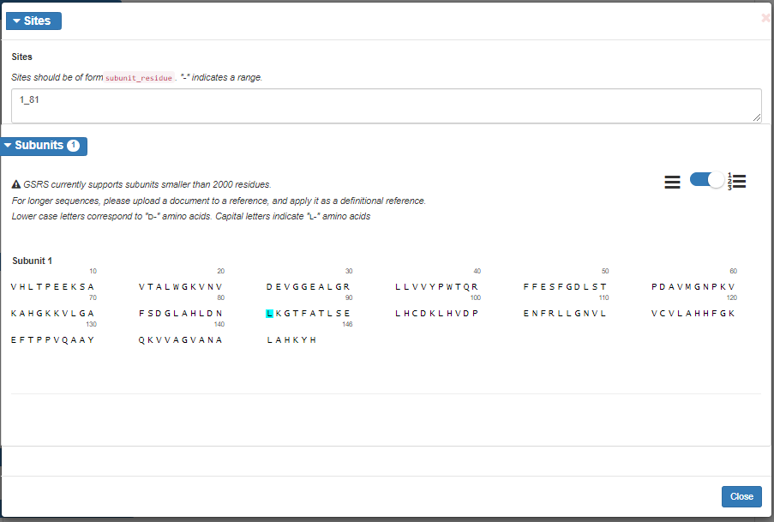

Figure 46 - Register Protein - Other Links - Site Selector

### Glycosylation

1. Click Glycosylation to expand the card
2. Select the Glycosylation Type - optional
3. For C, N and O Glycosylation Sites, click and the current sequence selector will be displayed
4. Sites should be in the form of subunit_residue, use hyphen “-“ to indicate a range.

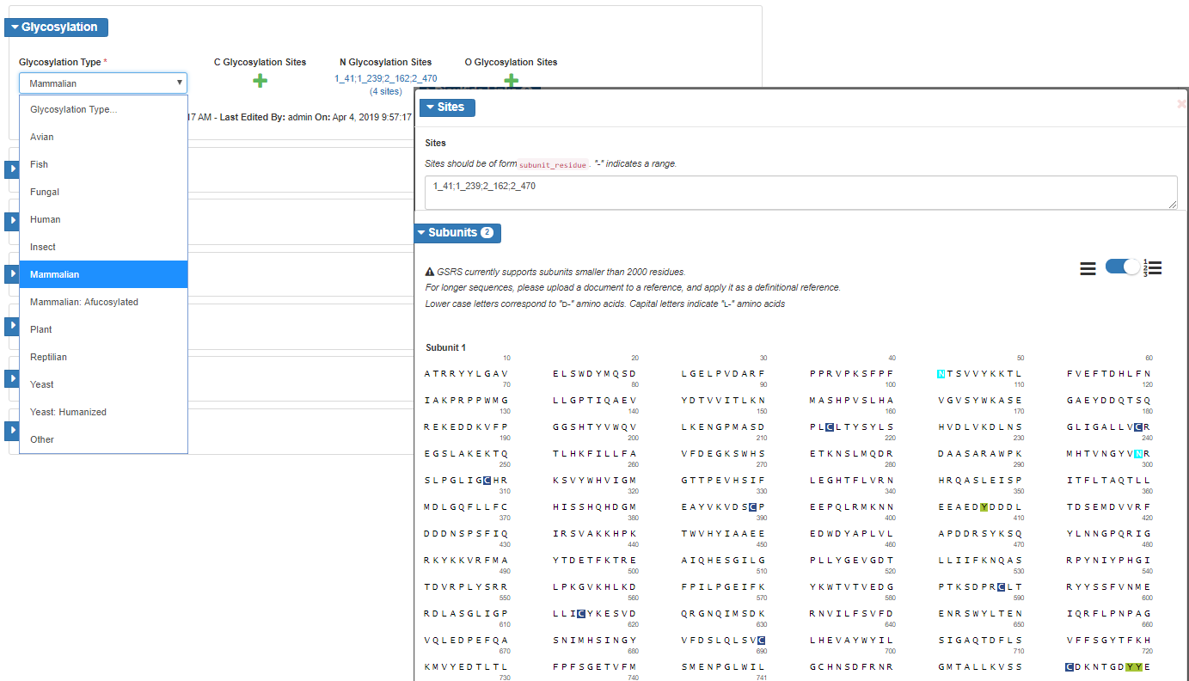

Figure 47 - Register Protein - Glycosylation

### Agent Modifications

The modifications without sufficient information to capture as structural modifications should be added as agent modifications.

1. To add an agent modification, click Agent Modification to expand the card
2. Click Add a modification button
3. Select the Modification Type, Modification Process, Modification Role, Agent substance (search & select), amount and Group
4. Repeat for additional agent modifications

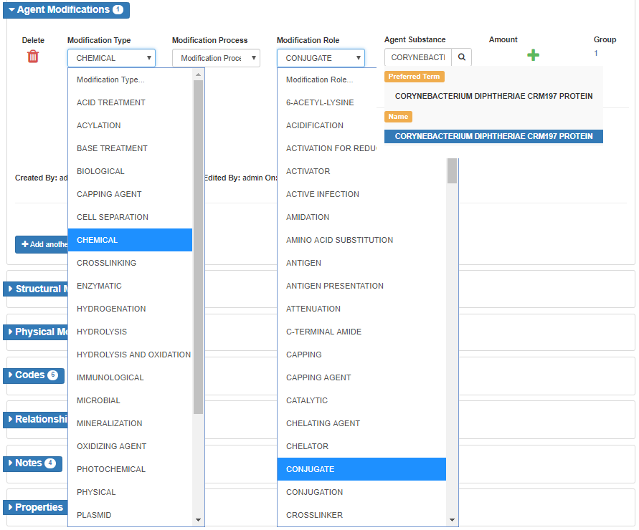

Figure 48 - Register Protein - Agent Modifications

### **Structural Modifications**

The common modifications are Amino Acid Removal, Amino acid replcament, Ligand Binding, Metal Binding and moiety.

1. To add a structural modification, click Structural Modification to expand the card
2. Click Add a modification button

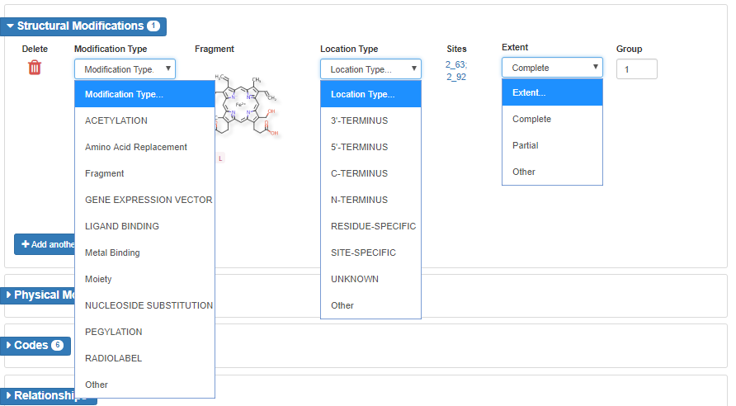

Figure 49 - Register Protein - Structural Modifications

1. Select the Modification Type
   1. Moiety: Use moiety modification for salts or solvates
   2. Ligand Binding or Metal Binding: Use to describe chelates, metal binding sites
2. Select the Fragment via substance search
   1. In some instances, the fragment substance may not be included in GSRS. Below is an example to register a fragment for Amino Acid Replacement
      1. Identify the substance type and register it using appropriate registration form
      2. Draw the structure to show cleary how the modifying group would connect to the amino acid
      3. If the modifying group has multiple connecting points consider it as multiple modifications and register all the possible isomers.
         1. Ex: Two lysine modifications and two leucine modifications for this example

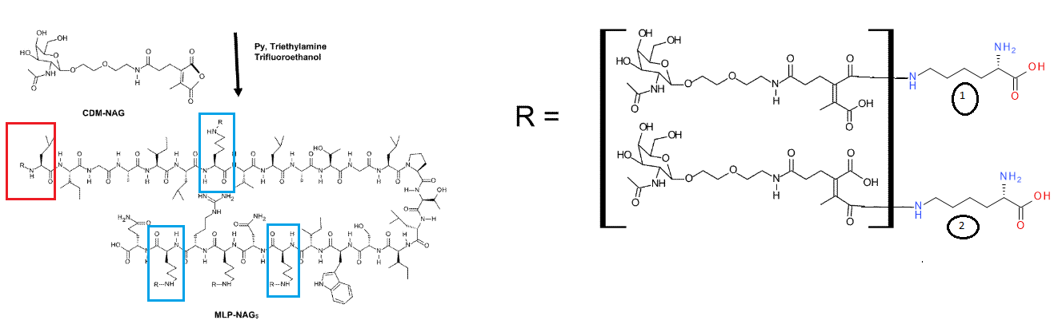

Figure 50 - Register Protein - Structural Modifications – Amino Acid Replacement Fragment

1. Select the location type:
   1. If the Location Type is Residue-Specific > enter the Residue Modified

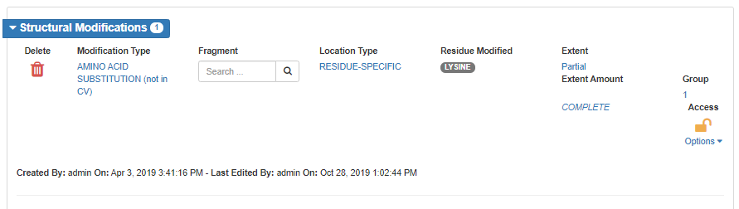

Figure 51 - Register Protein - Structural Modifications - RESIDUE-SPECIFIC Location Type

* 1. If the Location Type is N-terminus, C-terminus or Site Specific > Click on  under Sites

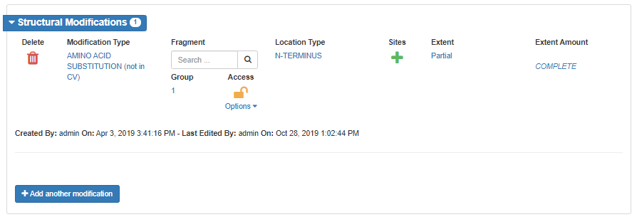

Figure 52 - Register Protein - Structural Modification – N-TERMINUS Location Type

* 1. In the site selector, click on the sequence or enter the sites

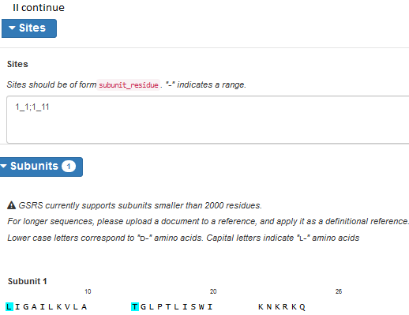

Figure 53 - Register Protein - Structural Modification – Site Selector

1. Select the Extent as complete or partial.
   1. If Partial click on  and enter the amount
2. Select Group to indicate parts of same modifications are grouped together
3. Repease for additional structural modifications

### **Physical Modifications**

Figure 54 - Register Proteins - Physical Modifications

1. To add a Physical Modification, click Physical Modifications to expand the card
2. Click Add a modification button
3. Select Modification Role, Parameters and Group as needed
   1. Parameters could be Heat, radiation etc.
4. Repeat for additional physical modifications

### Codes

Same as in Chemical registration - Codes

### Relationships

Same as in Chemical registration - Relationships

### Notes

Same as in Chemical registration - Notes

### Properties

Same as in Chemical registration - Properties

### References

Same as in Chemical registration - References

### Submit

Same as in Chemical registration - Submit

# Nucleic Acids

## Check for Duplicates

There are several options to check for duplicates (using all will ensure an exhaustive search).

* Search by name/code (CAS RN or another identifiers) using:
  + Global Search
  + Advanced Search (FDA Only)
  + Query Builder
* Sequence search

### Global Search

Same as in Chemical - Check for Duplicates - Global Search

### Sequence Search

1. From the navigation pane, select Sequence Search
2. Set Search Identity to 0.95
3. Set the Cutoff Type to Global alignment match
   1. Contains Alignment match is good for partial sequences.
4. Set the Sequence Type to Nucleic Acid
5. Paste the sequence in Query Sequence box
6. Click the Clean Sequence button
   1. The clean sequence tool removes numbers, spaces etc. X is considered as a modified base.
7. Click Search.

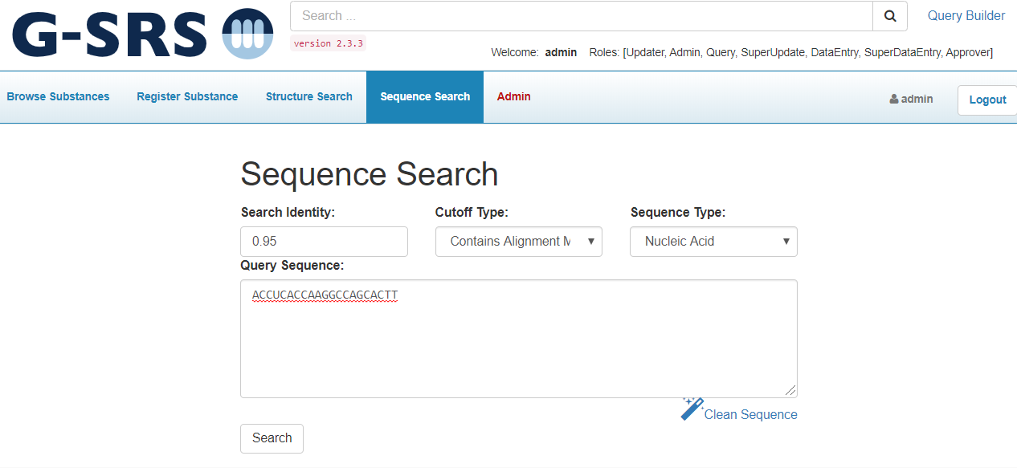

Figure 55 - Sequence Search - Nucleic Acid

1. Review the results/ alignment match to identify any duplicates

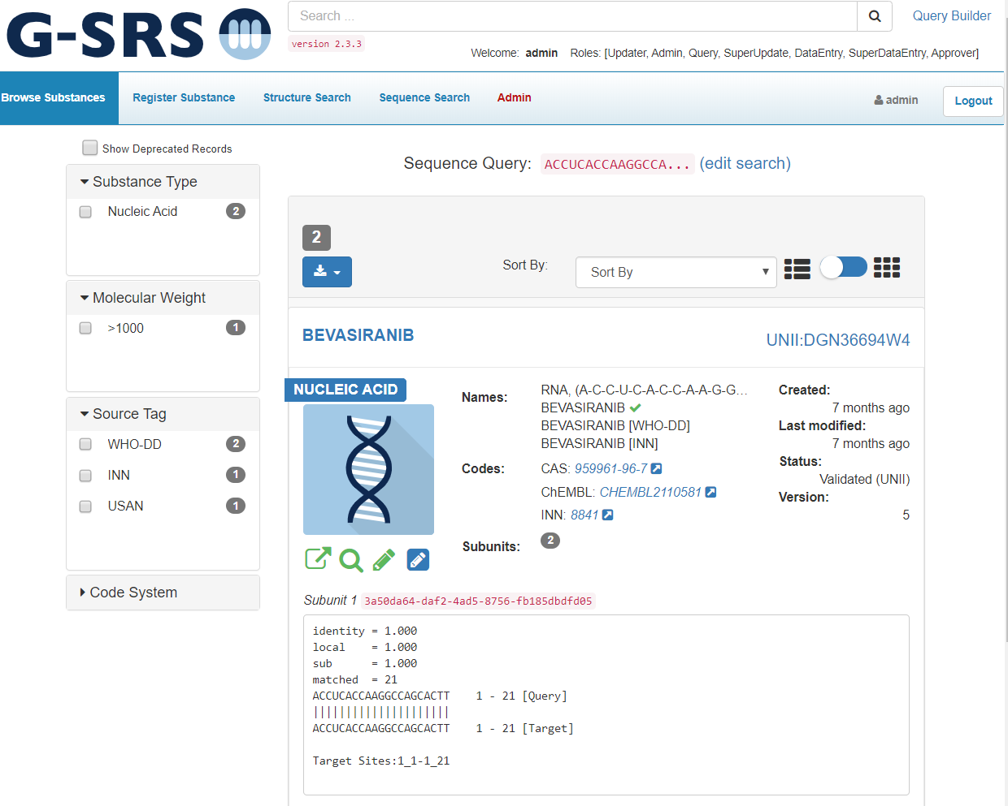

Figure 56 - Sequence Search - Nucleic Acid Results

## Nucleic Acid Registration

After verifying the substance is not registered in GSRS, use the Nucleic Acid Registration form to register the new substance. User accounts with registration permissions will have access to the registration menus. If you believe your account is not properly configured, contact your site admin.

1. From the GSRS homepage navigation pane, select Register Substance
2. All substance types will be displayed, select “Register a Nucleic Acid”



Figure 57 - GSRS Homepage - Register Substances

1. The nucleic acid registration form will be displayed. Section cards are collapsible to ease navigation, however the elements in this form are:
2. Definitional Information
3. Names
4. Nucleic Acid Classification
5. Subunits
6. Sugars
7. Linkages
8. Agent modification
9. Structural modification
10. Physical modification
11. Code
12. Relationships
13. Notes
14. Properties
15. References

### Definitional Information

Same as in Chemical registration - Definitional Information

### Names

Same as in Chemical registration - Names

### Nucleic Acid Classification

1. Click on Nucleic Acid Classification to expand the card
2. Select Nucleic Acid Type, Nucleic Acid Subtype, Sequence Origin, Sequence Type
3. Access level should be protected if the sequence information is not public, even if name and target information is public

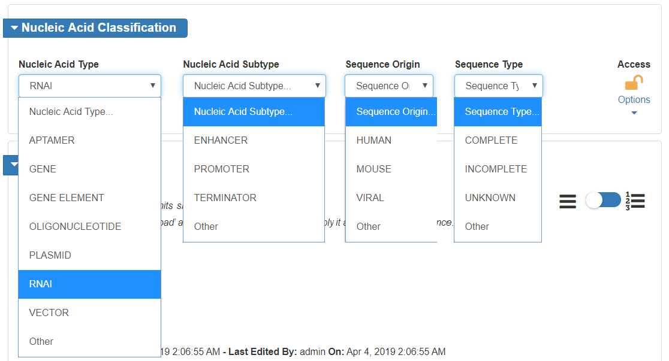

Figure 58 - Register Nucleic Acid - Classification

### Subunits

Same as in Protein registration - Subunits

### Sugars

1. Click Sugars to expand the Sugars card
2. Click Add sugar button

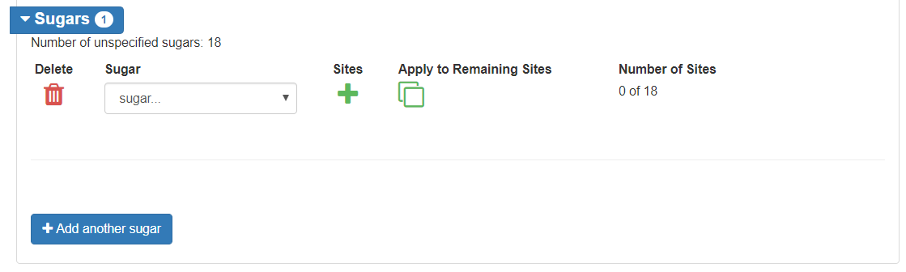

Figure 59 - Register Nucleic Acid - Sugars

1. If the nucleic acid has one sugar, to add the sites > click on Apply to Remaining Sites and it will auto populate all the sites
2. If more than one sugar, Click on  for the site selector pop-up.
   1. Either slect or type in the text box in the format subunit_residue; use “-“ for a range

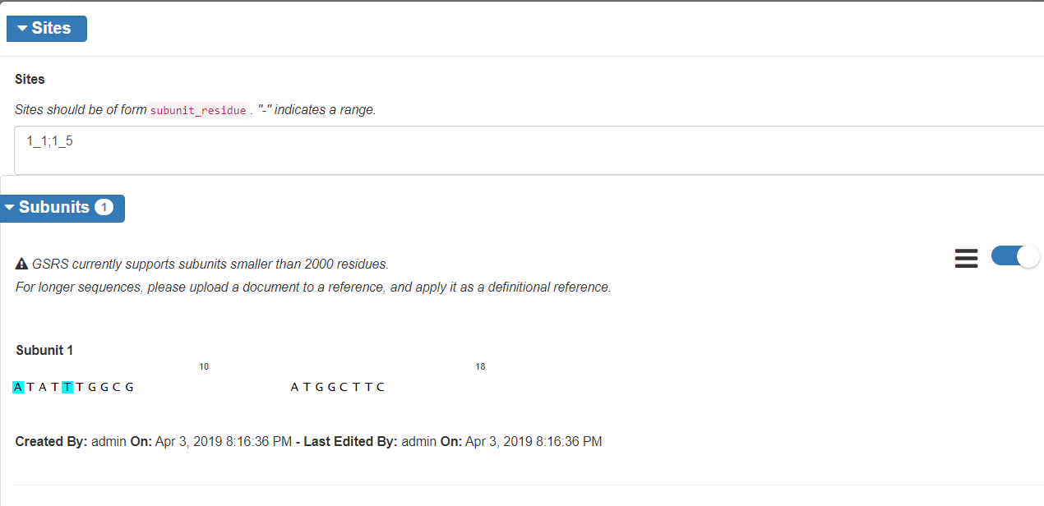

Figure 60 - Register Nucleic Acid - Sugars - Site Selector

1. Repeat for additional sugars

### Linkages

1. Click Linkages to expand the Linkages card
2. Click Add linkage button

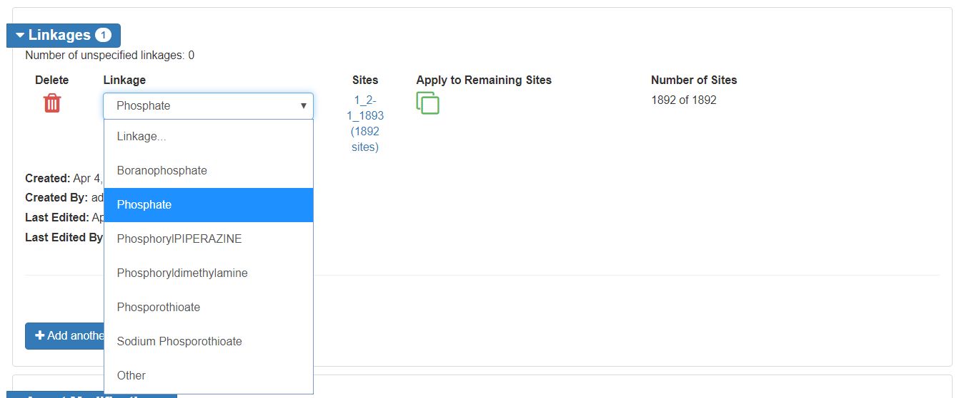

Figure 61 - Register Nucleic Acid - Linkages

1. If the nucleic acid has one linkage, to add sites > click on Apply to Remaining Sites and it will auto populate all the sites
2. If more than one sugar, Click on  for the site selector pop-up.
   1. Either slect or type in the text box in the format subunit_residue; use “-“ for a range
3. Repeat for additional linkages

### Agent Modifications

Same as in Protein registration - Agent Modifications

### Structural Modifications

Follow the steps in the Protein registration – Structural Modifications.

The common structural modifications for nucleic acids are:

* Nucleoside substitution - 5’-terminus location type
* Nucleotide substitution - invert sugars with 3’-3’ linkages
* Nucleobase substitution - for inner base modifications

Note: Nucleoside substitution has been using for both 5’ and inner base modifications to remove the ambiguty of the connectivity between base and sugar. This practice may have to continue with unusual bases

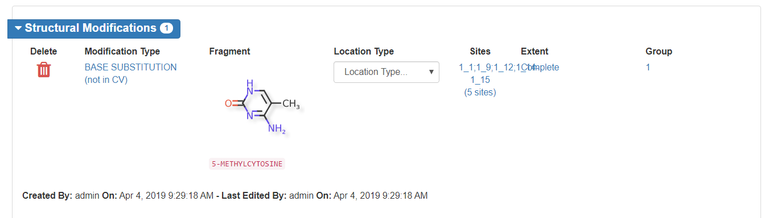

Figure 62 - Register Nucleic Acid - Structural Modifications

**Fragment registration for Nucleoside/nucleotide substitution**:

Follow the steps in the Protein Registration – Fragment section to identify the substance type and register it using appropriate registration form. Draw the structure to show clealy how modifing group would connect to the nucleoside/nucleotide.

### Physical Modifications

Same as in Protein registration - Physical Modifications

### Codes

Same as in Chemical registration - Codes

### Relationships

Same as in Chemical registration - Relationships

### Notes

Same as in Chemical registration - Notes

### Properties

Same as in Chemical registration - Properties

### References

Same as in Chemical registration - References

### Submit

Same as in Chemical registration - Submit

# Polymers

## Check for Duplicates

There is only one systematic way to search for polymer duplicates, using the Global Search feature.

### Global Search

Same as in Chemical - Check for Duplicates - Global Search

## Polymer Registration

After verifying the substance is not registered in GSRS, use the Polymer Registration form to register the new substance. User accounts with registration permissions will have access to the registration menus. If you believe your account is not properly configured, contact your site admin.

1. From the GSRS homepage navigation pane, select Register Substance
2. All substance types will be displayed, select “Register a Polymer”



Figure 63 - GSRS Homepage - Register Substances

1. The polymer registration form will be displayed. Section cards are collapsible to ease navigation, however the elements in this form are:
2. Definitional Information
3. Names
4. Polymer Classification
5. Monomers and Starting materials
6. Idealized Structure
7. Structural Units
8. Agent modification
9. Structural modification
10. Physical modification
11. Code
12. Relationships
13. Notes
14. Properties
15. References

### Definitional Information

Same as in Chemical registration - Definitional Information

### Names

Same as in Chemical registration - Names

### Polymer Classification

1. Click on Polymer Classification to expand the card
2. Select Polymer Class, Polymer Subclass, Polymer Geometry, Polymer Source Type, and Source Material
3. The Polymer Subclass is a text field with suggestions
4. If the substance is natural modified polymer, Source Material (search box) could be added.
   1. It is a search field and should be in the system, if not register.
5. Access level should be protected if the defining information is not public, even if the name is public.

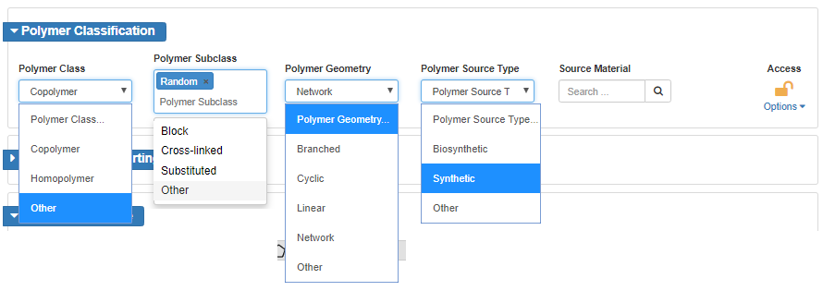

Figure 64 - Polymer Registration - Polymer Classification

Monomers and Starting Materials

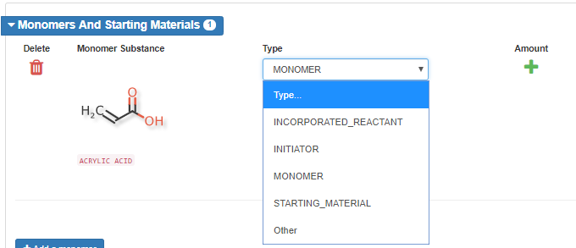The monomers and starting materials should be preregistered.

1. Click Monomers and Starting Materials to expand the card.
2. Monomer Substance is a search field for any substance within GSRS
3. Select the appropriate type from the drop down

Figure 65 - Polymer Registration – Monomers and Starting Materials

1. To add the amount, click on 
2. The type should be Mol Ratio or Weight ratio.
   1. The amount could be a range, average or limits.
   2. The units should be per polymer for homopolymers and no units for copolymers.

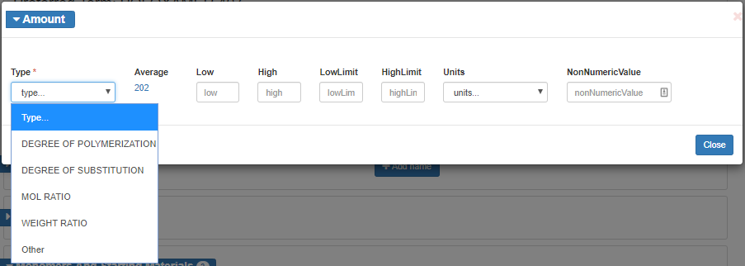

Figure 66 - Polymer Registration - Monomers and Starting Materials - Amount

### Idealized Structure

Follow the steps to import the structure similar to the chemical registration structure.

* The bracket types [ ] can be found in the JS Draw Canvas tool bar
  + SRUs can be labelled as you draw them
  + Generic brackets can be used for substitutions
* Free sites can be used to show the possible sites of substitution. To create free sites:
  + Bring the cursor to the site
  + Do not click the site, but on hover the site should high in green
  + Use the keyboard to hold Shift and * together

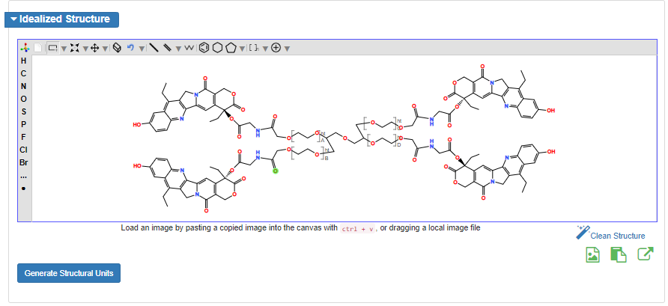

Figure 67 - Polymer Registration - Brackets and Free Site

### Structural Units

1. Click Structural Units to expand the card
2. From the Idealized Structure canvas, click the Generate Structural Units button
   1. The values can be manually updated

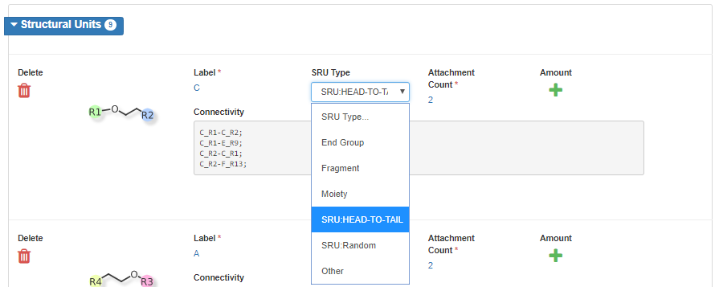

Figure 68 - Polymer Registration - Structural Units

1. Click on to add amount. Amount type should be:
   1. Degree of polymerization for structural repeat units
   2. Degree of Substitution for substituents.
   3. The amount can be a range, average or limits.
   4. Any additional information can be captured under Non numerical values

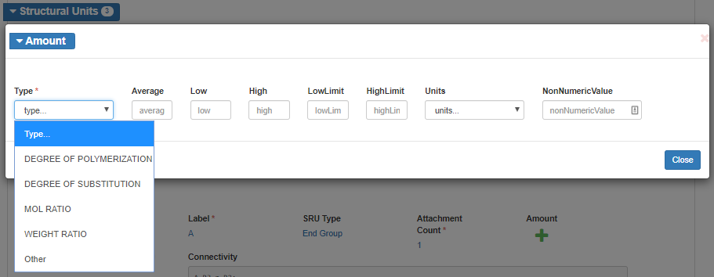

Figure 69 - Polymer Registration - Structural Unit – Amounts

### Agent Modifications

Same as in Protein registration - Agent Modifications

### Structural Modifications

The Fragments with undefined connection points to SRU could be captures as structural modifications. Follow the steps in the Protein registration – Structural Modifications.

Note: The system would generate structral units for these fragmants too (kind of redundant).

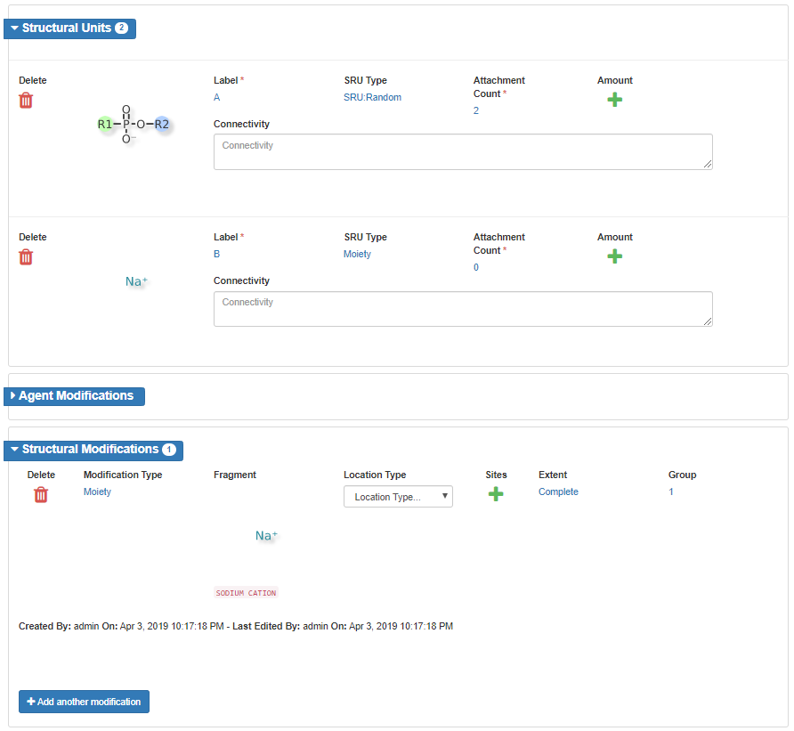

Figure 70 - Polymer Registration - Structural Modifications - Redundancy

### Physical Modifications

Same as in Protein registration - Physical Modifications

### Codes

Same as in Chemical registration - Codes

### Relationships

Same as in Chemical registration - Relationships

### Notes

Same as in Chemical registration - Notes

### Properties

Same as in Chemical registration - Properties

### References

Same as in Chemical registration - References

### Submit

Same as in Chemical registration - Submit

# Structurally Diverse

## Check for Duplicates

There is only one systematic way to search for structurally diverse duplicates, using the Global Search feature.

### Global Search

Same as in Chemical - Check for Duplicates - Global Search

## Structurally Diverse Registration

After verifying the substance is not registered in GSRS, use the Structurally Diverse Registration form to register the new substance. User accounts with registration permissions will have access to the registration menus. If you believe your account is not properly configured, contact your site admin.

1. From the GSRS homepage navigation pane, select Register Substance
2. All substance types will be displayed, select “Register a Structurally Diverse Substance”



Figure 71 - GSRS Homepage - Register Substances

1. The structurally diverse registration form will be displayed. Section cards are collapsible to ease navigation, however the elements in this form are:
2. Definitional Information
3. Names
4. Source Material
5. Source Material Record Type
6. Hybrid Organism Details
7. Agent modification
8. Structural modification
9. Physical modification
10. Code
11. Relationships
12. Notes
13. Properties
14. References

### Definitional Information

Same as in Chemical registration - Definitional Information

### Names

Same as in Chemical registration - Names

### Source Material

1. Click Source Material to expand the card
2. Select the Source Material Class and Source Material Type
   1. If you select Source Material Class = Organism:
      1. You will also have the opportunity to add the Source Material State
      2. An additional card for Organism Detail will also appear as part of the form

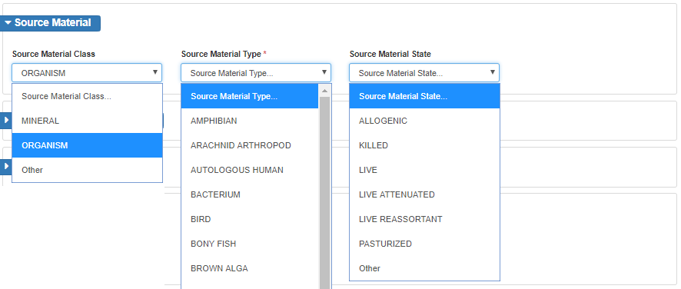

Figure 72 - Structurally Diverse Registration - Source Material

### Source Material Record Type

Figure 73 – Structurally Diverse Registration - Source Material Record Type

1. Click Source Material Record Type to expand the card
2. Select either:
   1. Whole - Whole organisms are plants, animals, microorganism, virus, modified virus, cell lines, modified cell lines.
   2. Part/Fraction - additional cards for Parent Organism Details and Parts and Fractions will appear as part of the form

### Organism Details

This card is displayed if the Source Material, Source Material Class field is set to Organism and Source Material Record Type is set to Whole

1. Click Organism Details to expand the card
2. Enter Organism Family, Organism Genus, Organism Species, Organism Author and Infraspecific Name
3. Options for Development Stage and Infraspecific Type are provided.

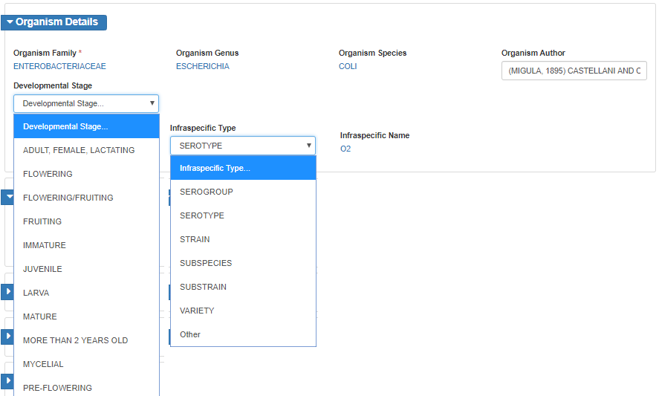

Figure 74 - Structurally Diverse Registration - Organism Details

### Hybrid Organism Details

Figure 75 - Structurally Diverse Registration - Hybrid Organism Details

If a whole organism is hybrid, the paternal and maternal organism details should be captured.

1. Click Hybrid Organism Details to expand the card
2. Use the substance search fields to populate Hybrid Paternal and Maternal Organism fields

### Parent Organism Details

This card is displayed if the Source Material Record Type is set to Part/Fraction (regardless of the Source Material, Source Material Class selection)

1. Click Parent Organism Details to expand the card
2. Use the search box to identify the parent substance
   1. If the substance is not in GSRS, please identify the substance type and register the new substance

### Parts and Fractions

This card is displayed if the Source Material Record Type is set to Part/Fraction (regardless of the Source Material, Source Material Class selection)

Figure 76 - Structurally Diverse Registration - Parent Organism Details

1. Click Parts and Fractions to expand the card
2. Select a Part from the list, multiple parts can be selected at one time
3. Select Part Location and Fraction Material Type from the lists
4. Enter the Fraction Name

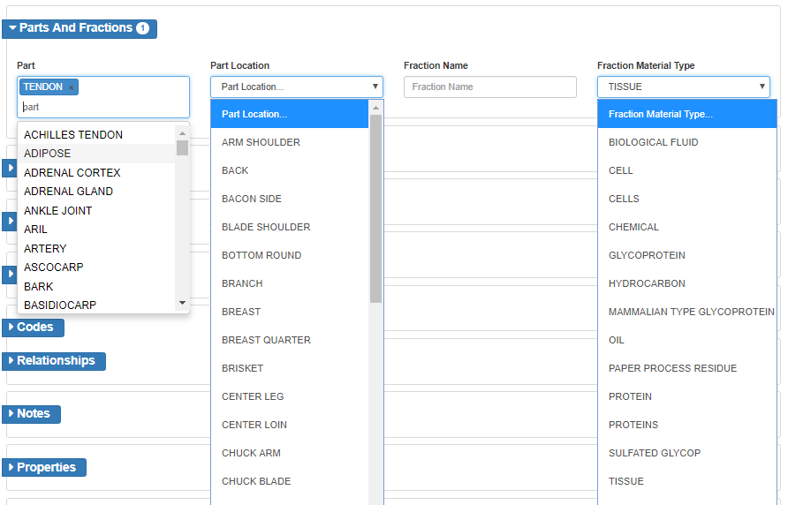

Figure 77 - Structurally Diverse Registration - Parts and Fractions

### Agent Modifications

Same as in Protein registration - Agent Modifications

### Structural Modifications

Follow the steps in the Protein registration – Structural Modifications.

### Physical Modifications

Same as in Protein registration - Physical Modifications

### Modifications for Gene and Cell Therapies Example

Gene therapy and cell therapy are rapidly evolving fields for treatment. These are complex modified biological materials and captured structurally diverse substances. All the modifications should be captured under these modifications.

Example: Ad5 [E1-, E2b-]-HER2/Neu vaccine ETBX-021: A cancer vaccine composed of a genetically engineered, replication-defective oncolytic adenovirus serotype 5 (Ad5) vector, in which the E1, E2b and E3 genes are deleted, that encodes a modified version of the tumor-associated antigen (TAA) human epidermal growth factor receptor 2 (HER2/neu; ErbB-2; ERBB2), with potential antineoplastic activity.

<https://www.cancer.gov/publications/dictionaries/cancer-drug/def/793072>

This was registered as structurally diverse whole organism with modifications.

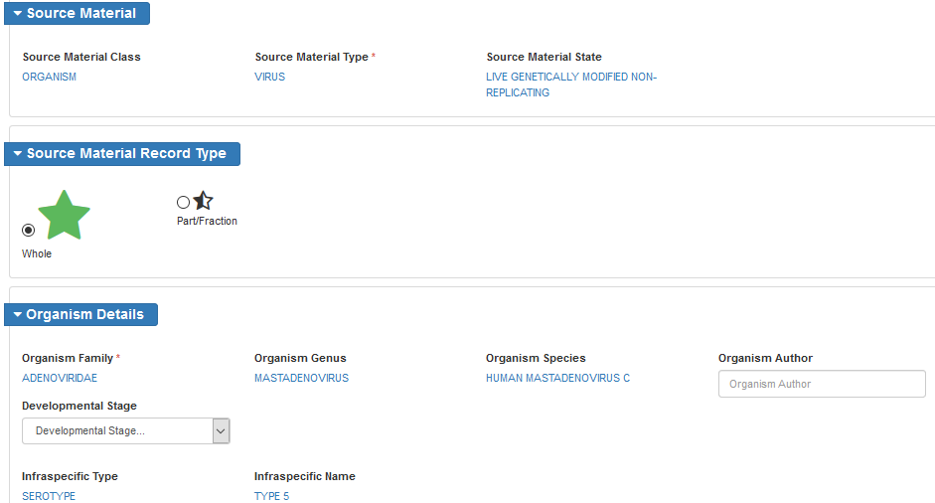

Figure 78 - Structurally Diverse Registration - Cancer Vaccine ETBX-021 Example

Most of the time, the sequence of deleted gene is not available. The expressed protein from that gene could be available. The available information has been captured when registering ETBX-021.

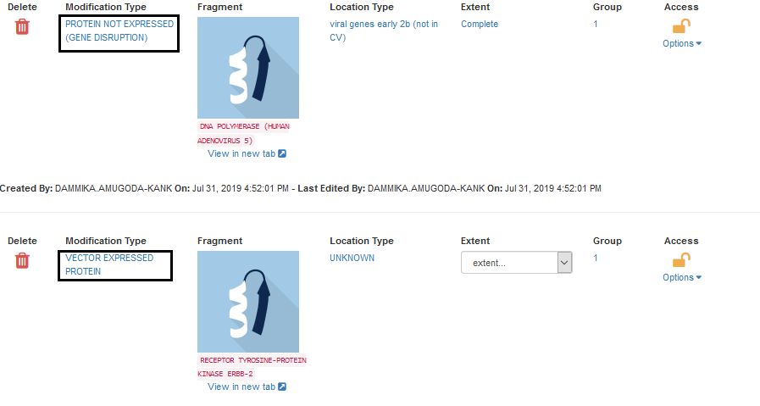

Figure 79 - Structurally Diverse Registration - Modifications for ETBX-021

### Codes

Same as in Chemical registration - Codes

### Relationships

Same as in Chemical registration - Relationships

### Notes

Same as in Chemical registration - Notes

### Properties

Same as in Chemical registration - Properties, Note that, capturing a Property may be important for cell/gene therapy drugs.

### References

Same as in Chemical registration - References

### Submit

Same as in Chemical registration - Submit

# Mixture

Substances that are isolated or synthesized together are considered a mixture. Common examples include coconut acid (Fatty acid isolated from coconut oil) or a mixture of isomers (most commercial products with chiral centers are mixtures of isomers).

## Check for Duplicates

There is only one systematic way to search for structurally diverse duplicates, using the Global Search feature.

### Global Search

Same as in Chemical - Check for Duplicates - Global Search. Note that, a search by a component name generates a short list of substances which may include all the mixtures with that component, this list should be reviewed for duplicates.

## Mixture Registration

After verifying the substance is not registered in GSRS, use the Mixture Registration form to register the new substance. User accounts with registration permissions will have access to the registration menus. If you believe your account is not properly configured, contact your site admin.

1. From the GSRS homepage navigation pane, select Register Substance
2. All substance types will be displayed, select “Register a Mixture”



Figure 80 - GSRS Homepage - Register Substances

1. The mixture registration form will be displayed. Section cards are collapsible to ease navigation, however the elements in this form are:
2. Definitional Information
3. Names
4. Mixture Details
5. Components
6. Agent modification
7. Structural modification
8. Physical modification
9. Code
10. Relationships
11. Notes
12. Properties
13. References

### Definitional Information

Same as in Chemical registration - Definitional Information

### Names

Same as in Chemical registration - Names

### Mixture Details

Figure 81 - Register Mixture - Mixture Details

If the mixture substance is a mixture of substances that are isolated together, the Source Material Parent should be captured.

1. Click Mixture Details to expand the card
2. Use the substance search box to search for the record for parent organism should be pre-registered
   1. If the substance is not in GSRS, determine the substance type and register the new record
3. Access level should be protected if the component information is not public, even if name is public.

### Components

1. Click Components to expand the card.
2. Click Add Component button
3. Use the Component Substance field to search GSRS for substances
4. Select the type from drop down
   1. Typically the type will be “must be present (all of)”

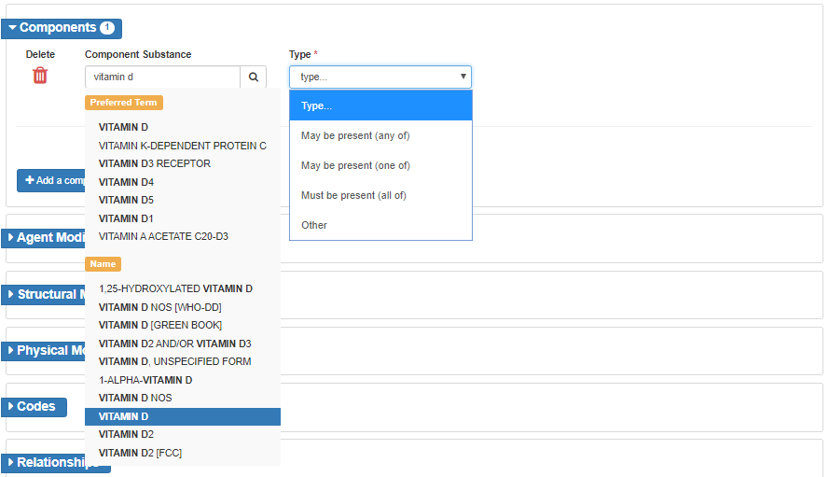

Figure 82 - Register Mixture - Components

### Agent Modifications

Same as in Protein registration - Agent Modifications

### Structural Modifications

Same as in Protein registration – Structural Modifications.

### Physical Modifications

Same as in Protein registration - Physical Modifications

### Codes

Same as in Chemical registration - Codes

### Relationships

Same as in Chemical registration - Relationships

### Notes

Same as in Chemical registration - Notes

### Properties

Same as in Chemical registration - Properties

### References

Same as in Chemical registration - References

### Submit

Same as in Chemical registration - Submit

# Concept

## Concept Registration

Concepts have no defining information but are collections of terms, codes and related information. They can be promoted to a defined substance later, when appropriate. Examples of concepts include herbal extract/tincture and biosimilars.

1. From the GSRS homepage navigation pane, select Register Substance
2. After verifying the substance is not registered in GSRS, use the Concept Registration form to register the new substance. User accounts with registration permissions will have access to the registration menus. If you believe your account is not properly configured, contact your site admin.
3. All substance types will be displayed, select “Register a Concept”



Figure 83 - GSRS Homepage - Register Substances

1. The concept registration form will be displayed. Section cards are collapsible to ease navigation, however the elements in this form are:
2. Definitional Information
3. Names
4. Code
5. Relationships
6. Notes
7. Properties
8. References

### Names

Same as in Chemical registration - Names

### Codes

Same as in Chemical registration - Codes.

### Relationships

Same as in Chemical registration - Relationships

* Use the relationship type Substance -> Sub_concept for herbal extracts/tincture and biosimilars
* Use the Constituent Always Present -> Parent relationship types for components

Figure 84 - Concept Registration - Relationships

### Notes

Same as in Chemical registration - Notes

### Properties

Same as in Chemical registration - Properties

### References

Same as in Chemical registration - References

### Submit

Same as in Chemical registration - Submit